

Capstone Project Report
Report 3 – Software Requirement Specification

– Ho Chi Minh City, October 2026 –
Table of Contents
I. Record of Changes 3
II. Software Requirement Specification 5
1. Product Overview 5
2. User Requirements 6
2.1 Actors 6
2.2 Use Cases 6
3. Functional Requirements 16
3.1 System Functional Overview 16
3.2 Account & Authentication 29
3.3 Locker Send 32
3.4 Locker Rental 36
3.5 Drone Delivery 38
3.6 Wallet, Promotion & Loyalty 43
3.7 Maintenance 44
3.8 Administration 47
3.9 AI Assistant 51
4. Non-Functional Requirements 52
4.1 External Interfaces 52
4.2 Quality Attributes 52
5. Requirement Appendix 53
5.1 Business Rules 53
5.2 Common Requirements 54
5.3 Application Messages List 55
5.4 Other Requirements - Status Values 56

I. Record of Changes
Date | A*  M, D | In charge | Change Description
13/09/2026 | A | huynqbse180211 | Initial SRS: product overview, actors (Customer, Receiver, Locker Technician, Drone Technician, Admin), 4 business flows, state diagrams
15/09/2026 | A | binhtntse182370 | Technician assignment, ticket SLA and SLA restriction for locker technicians
16/09/2026 | A | huynqbse180211 | Pickup code sent to receiver by SMS / email; admin reports for orders, payments and revenue; configurable business rules
20/09/2026 | M | viltyse182544 | Drone dispatch: RESERVED drone status, lock against double accept, battery / landing pad re-check before launch
20/09/2026 | A | binhtntse182370 | Three ways to open a box: BLE proximity, QR scan, kiosk PIN
21/09/2026 | A | huynqbse180211 | AI assistant (RAG); ticket routing and periodic inspection; separate roles LOCKER_TECHNICIAN / DRONE_TECHNICIAN
21/09/2026 | M | nhatkse182290 | Admin changes drone status / battery without claim; drones on mission cannot be edited
24/09/2026 | A | binhtntse182370 | Wallet withdrawal; rental overdue must pay to unlock
25/09/2026 | A | viltyse182544 | Mandatory drone loading step (weight, seal code, checklist) before launch
27/09/2026 | A | huynqbse180211 | Locker controller by Pi GPIO; MQTT contract backend - locker; assign Pi to locker on admin web
27/09/2026 | M | binhtntse182370 | Box incident resolution: relocate parcel to new box, hand over, seal to hub, lock box
01/10/2026 | M | viltyse182544 | Drone tracking for customer / dispatcher / admin; STANDARD stages confirmed by dispatcher
07/10/2026 | A | viltyse182544 | Real drone telemetry (MAVLink -> MQTT) and live position
07/10/2026 | M | binhtntse182370 | Refund to customer bank account by admin with receipt (REFUND_PENDING)
09/10/2026 | M | viltyse182544 | Drone flight failure, mission record kept, unpaid / undispatched timeouts
10/10/2026 | A | nhatkse182290 | Drone parcel drop incident and recovery
12/10/2026 | A | viltyse182544 | Drone home pickup
13/10/2026 | D | huynqbse180211 | Removed MoMo, VNPay and cash payment; only SePay bank transfer (VietQR)
13/10/2026 | A | huynqbse180211 | Phone login (Firebase OTP), kiosk QR login, delegated pickup, incoming orders for receivers
17/10/2026 | A | nhatkse182290 | Technician shift / presence
18/10/2026 | A | huynqbse180211 | Pay with loyalty points, tiers by total earned points, vouchers per locker
19/10/2026 | M | huynqbse180211 | Locker order payment reconciliation; payment simulator for testing
19/10/2026 | M | binhtntse182370 | Box cannot open until overtime fee is paid; rules synced to app and kiosk
20/10/2026 | M | nhatkse182290 | Parcel drop incident: free redelivery and compensation refund
21/10/2026 | A | nhatkse182290 | Drone hardware device management and drone IoT logs
*A - Added M - Modified D - Deleted

II. Software Requirement Specification

1. Product Overview
Lock.R is a smart locker system combined with drone delivery. Customers rent locker boxes to send parcels to another person or to keep their own items for a number of hours, and can order a drone to carry a parcel between two lockers that have a landing pad (or from a pickup location to a locker). Each locker is a cabinet of boxes controlled by a Raspberry Pi with a touch-screen kiosk; receivers open a box with a 6-digit PIN or a QR code and do not need an account. Locker technicians and the drone team operate and maintain the system through the mobile app; administrators manage everything through a web portal protected by 2-factor login. An AI assistant answers questions from internal documents and from the user's own orders.
The system is delivered as a mobile app (Android / iOS) and mobile web, an admin web, a kiosk web UI on each locker, and a backend of Spring Boot microservices (gateway, auth, user, order, locker, payment, notification, IoT, store, loyalty, assistant) deployed on an Azure VM. Production domains: locker-drone.tech (landing), admin.locker-drone.tech (admin) and api.locker-drone.tech (API). The context diagram below shows the boundary of the system, its users, the devices it controls and the external services it depends on.
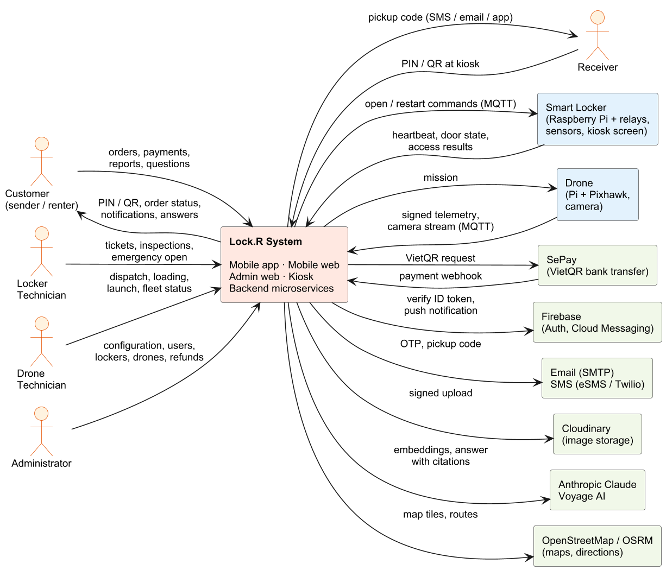
Figure 1. Context diagram of the Lock.R system

2. User Requirements

2.1 Actors
# | Actor | Description
1 | Guest | Person who has not logged in. Can view the landing page, find lockers / stores, register, log in and reset the password.
2 | Customer | Registered user (role CUSTOMER) using the mobile app, mobile web or kiosk. Sends parcels through lockers, rents boxes by the hour, books drone deliveries, pays by VietQR / wallet, manages wallet, vouchers and loyalty points, reports incidents, rates orders and asks the AI assistant.
3 | Receiver | Person who receives a parcel. Without an account the receiver only needs the 6-digit PIN / QR code (SMS, email or shared by the sender) to open the box at the kiosk; with an account (same phone or email) the receiver also sees the order in 'Waiting for pickup'.
4 | Locker Technician | Staff (role LOCKER_TECHNICIAN) who maintains lockers: claims and resolves tickets within SLA, performs periodic inspections, opens boxes in emergencies, restarts locker controllers and recovers dropped drone parcels.
5 | Drone Technician | Staff (role DRONE_TECHNICIAN) of the flight team: accepts drone orders, picks up parcels at the customer's location, confirms loading, launches drones, confirms flight stages, reports failed flights / parcel drops and maintains the drone fleet.
6 | Administrator | Operator (role ADMIN) using the admin web with 2-factor login. Manages users, staff, stores, lockers, boxes, controllers, drones, orders, payments, refunds, withdrawals, promotions, loyalty, feedback, notifications, business settings and the AI knowledge base.
7 | Locker controller (Raspberry Pi) | Device inside each locker. Drives relays, lock signals, door sensors and the sliding lid by GPIO, runs the kiosk UI, sends heartbeats and door states and executes open / restart commands received over MQTT.
8 | System scheduler | Background jobs of the backend that cancel unpaid orders, release boxes, send reminders, expire overdue orders, reconcile box states and time out drone orders.

2.2 Use Cases

2.2.1 Diagram(s)
The use cases are split into six diagrams by user group. «include» marks a use case that is always performed as part of another; «extend» marks an optional or conditional one.
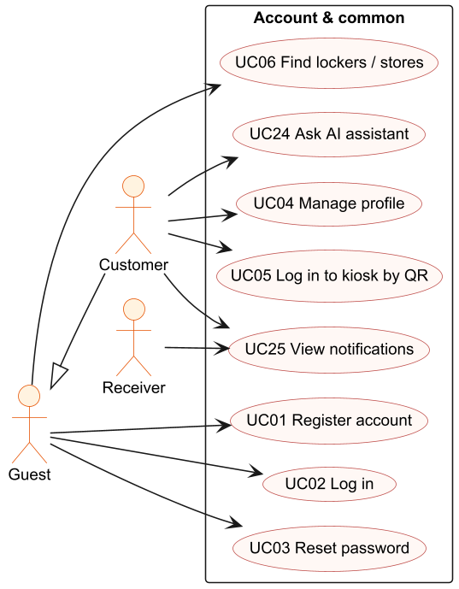
Figure 2. Use case diagram - Account & common functions
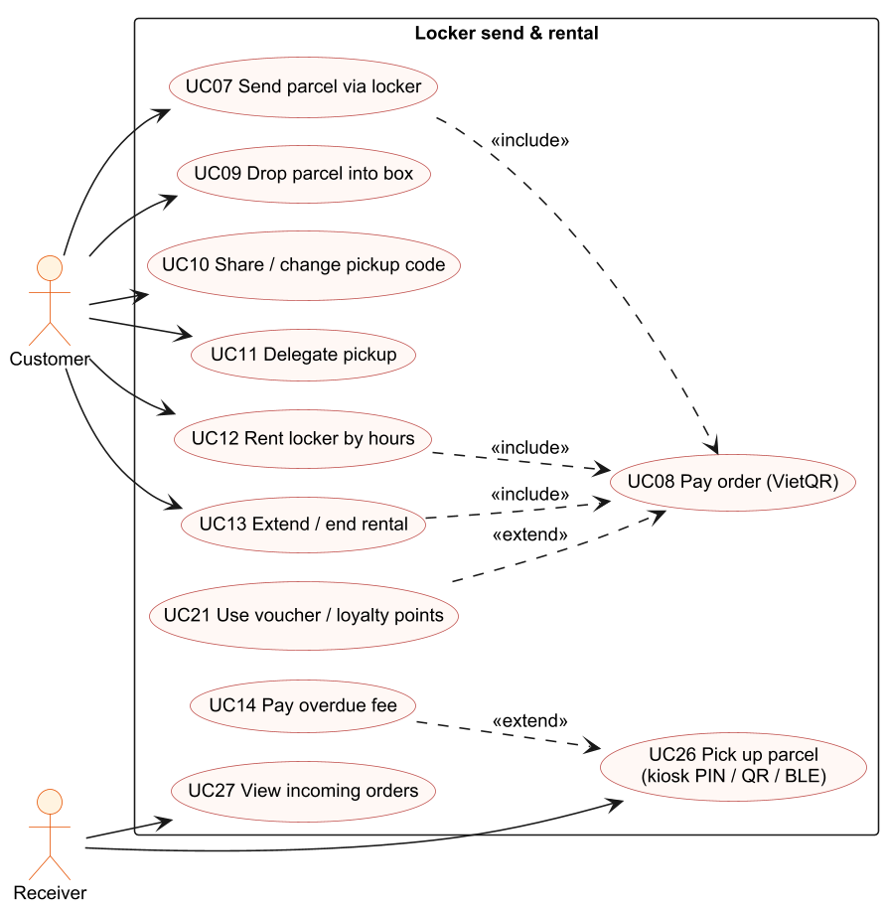
Figure 3. Use case diagram - Locker send & rental
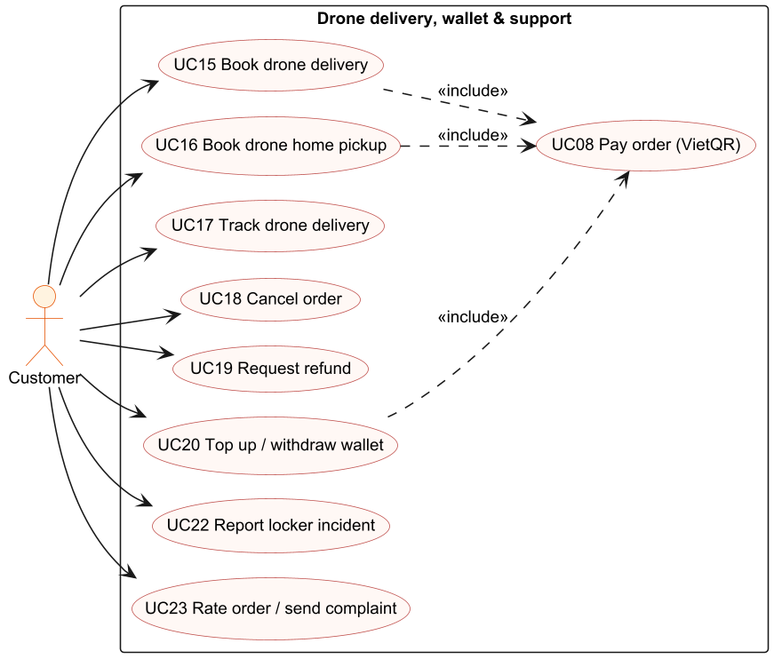
Figure 4. Use case diagram - Drone delivery, wallet & support
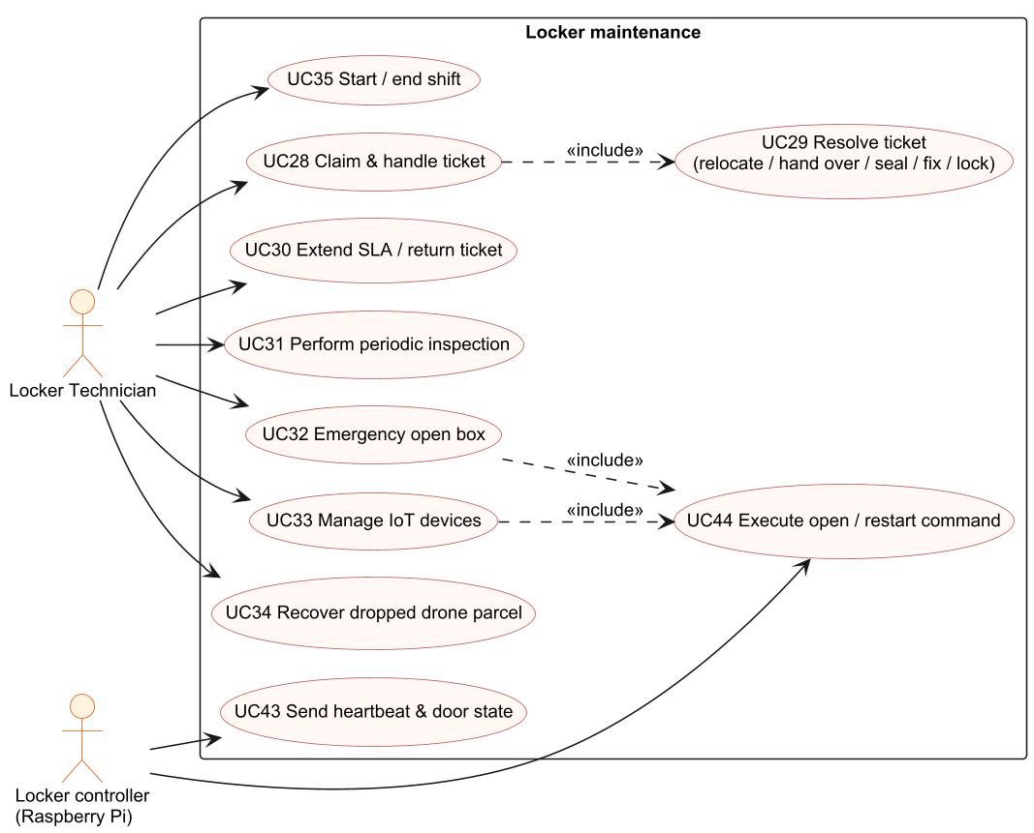
Figure 5. Use case diagram - Locker maintenance
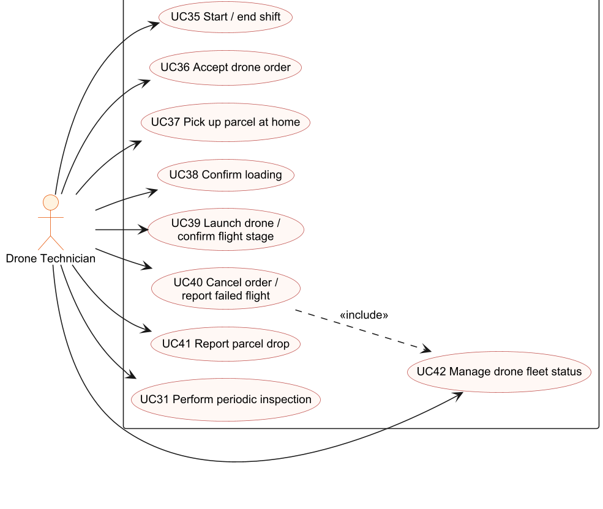
Figure 6. Use case diagram - Drone operation
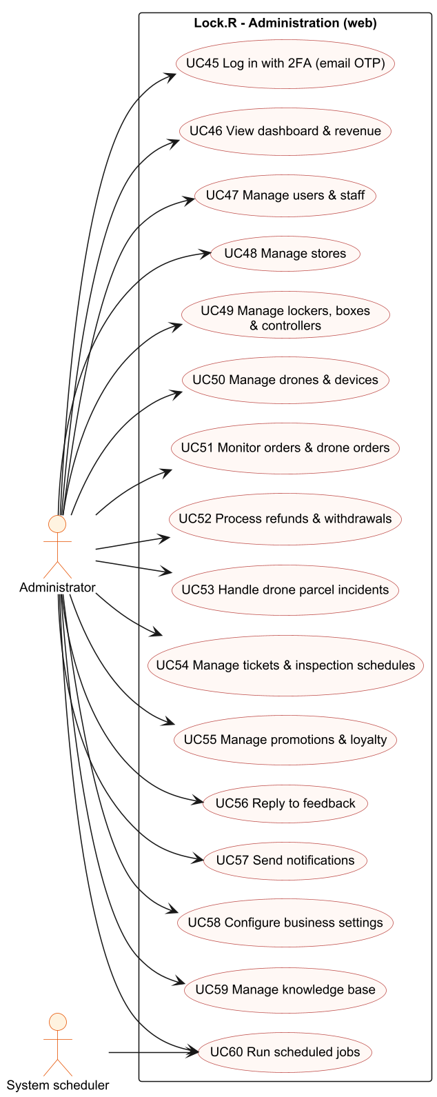
Figure 7. Use case diagram - Administration

2.2.2 Descriptions
ID | Use Case | Actors | Use Case Description
UC01 | Register account | Guest | Create a CUSTOMER account with full name, email, phone and password, or with Google / phone OTP (Firebase) followed by 'Complete registration'.
UC02 | Log in | Guest | Log in by email + password, Google, phone + Firebase OTP or email OTP. The app opens the home page matching the user's role.
UC03 | Reset password | Guest | Receive a 6-digit OTP by email and set a new password.
UC04 | Manage profile | Customer | View / edit profile and avatar, change password, save the bank account used for refunds.
UC05 | Log in to kiosk by QR | Customer | Scan the QR shown on the kiosk (valid 2 minutes) with the app and confirm, so the kiosk is logged in without typing.
UC06 | Find lockers / stores | Guest, Customer | Search stores and lockers on list and map, see free boxes, online status and directions.
UC07 | Send parcel via locker | Customer | Choose locker and box size (or a box on the map), enter receiver phone / name / email, apply voucher / points and create a SEND order; the box is reserved.
UC08 | Pay order (VietQR) | Customer | Pay by bank transfer with a server-generated VietQR; the SePay webhook confirms the payment and the order becomes PAID.
UC09 | Drop parcel into box | Customer | Open the reserved box from the app or with the send code at the kiosk, put the parcel in, close the door and confirm.
UC10 | Share / change pickup code | Customer | Share the pickup PIN / QR via Zalo, Messenger or SMS; regenerate the PIN if it was leaked.
UC11 | Delegate pickup | Customer | Authorize another phone number to pick up a STORING order; the PIN is regenerated for the delegate.
UC12 | Rent locker by hours | Customer | Choose locker, box type and number of hours, pay and start the rental; the PIN can be used many times during the rental.
UC13 | Extend / end rental | Customer | Extend the rental (pay the extra hours) or end it by taking all items and closing the box.
UC14 | Pay overdue fee | Customer, Receiver | When the pickup deadline / rental time is over, pay the overtime fee before the box can be opened.
UC15 | Book drone delivery | Customer | Choose the receiver locker and box, parcel type, weight level, declared value and receiver, accept the prohibited-goods commitment, create and pay the drone order.
UC16 | Book drone home pickup | Customer | Choose a pickup location so a drone technician collects the parcel and brings it to the drone.
UC17 | Track drone delivery | Customer, Receiver | Follow the timeline of flight stages, the A-to-B map and the live drone position.
UC18 | Cancel order | Customer | Cancel an order that is still cancellable (e.g. drone order awaiting dispatch); paid orders go to REFUND_PENDING.
UC19 | Request refund | Customer | Request a refund of a paid order with reason and evidence photos and follow its status.
UC20 | Top up / withdraw wallet | Customer | Top up the Lock.R wallet by VietQR, withdraw to a bank account and see transaction history.
UC21 | Use voucher / loyalty points | Customer | Save promotions, apply a voucher valid for the chosen locker and pay part of the order with loyalty points.
UC22 | Report locker incident | Customer | Report a faulty box / locker with title, description and photos; a ticket is opened and the box becomes FAULT.
UC23 | Rate order / send complaint | Customer | Rate a completed order with stars and comment or send a complaint; receive the admin reply.
UC24 | Ask AI assistant | Customer, Locker Technician, Drone Technician | Ask questions about services, rules or own orders and receive answers with citations.
UC25 | View notifications | All logged-in users | See push / in-app notifications, open the related screen, delete one or all.
UC26 | Pick up parcel | Receiver | Open the box with PIN or QR at the kiosk (or BLE one-tap in the app) and take the parcel; the order is completed.
UC27 | View incoming orders | Receiver | Receiver with an account sees orders sent to his phone / email with the PIN and order details.
UC28 | Claim & handle ticket | Locker Technician | Claim an OPEN ticket, add progress logs and photos.
UC29 | Resolve ticket | Locker Technician | Resolve by relocating the parcel to a new box, handing it over (customer PIN required), sealing it to the hub, fixing on site or locking the box; after-fix photo.
UC30 | Extend SLA / return ticket | Locker Technician | Extend the SLA with a reason (max 2 times x 24 h) or return the ticket to the queue.
UC31 | Perform periodic inspection | Locker Technician, Drone Technician | Fill the inspection checklist (Pass / Fail per item, photos); failed items open a ticket automatically.
UC32 | Emergency open box | Locker Technician | Send a master open command with a mandatory reason; the result is shown (opened / timeout / error / jammed).
UC33 | Manage IoT devices | Locker Technician | See controllers of assigned lockers, last seen time, restart a controller, mark a device faulty.
UC34 | Recover dropped drone parcel | Locker Technician | Accept a recovery task, check in by GPS, collect evidence and hand the parcel over to the hub.
UC35 | Start / end shift | Locker Technician, Drone Technician | Start or end the working shift; location is shared while on duty.
UC36 | Accept drone order | Drone Technician | Accept a paid drone order whose parcel is ready and choose an idle drone with enough battery.
UC37 | Pick up parcel at home | Drone Technician | Accept a pickup offer, go to the customer's location and confirm pickup with a parcel photo.
UC38 | Confirm loading | Drone Technician | Enter the measured weight, use the system seal code and tick the 3-item checklist before launch.
UC39 | Launch drone / confirm flight stage | Drone Technician | Launch within flight hours and confirm stages for STANDARD orders without telemetry.
UC40 | Cancel order / report failed flight | Drone Technician | Cancel before launch or report a failed flight with reason; the drone becomes FAULT.
UC41 | Report parcel drop | Drone Technician | Report that the parcel fell during flight; delivery stops and an incident is opened.
UC42 | Manage drone fleet status | Drone Technician | Claim a drone, change status, update battery and write maintenance notes.
UC43 | Send heartbeat & door state | Locker controller | Periodically report online status and door open / closed state of each box.
UC44 | Execute open / restart command | Locker controller | Open a box or restart the controller process when a command arrives and report the result.
UC45 | Log in with 2FA | Administrator | Log in to the admin web with email + password and a 6-digit OTP sent by email.
UC46 | View dashboard & revenue | Administrator | See revenue, orders by status, peak hours, user growth and top locations.
UC47 | Manage users & staff | Administrator | Search users, create technicians, lock / unlock and delete accounts.
UC48 | Manage stores | Administrator | Create, update and deactivate stores.
UC49 | Manage lockers, boxes & controllers | Administrator | Create lockers and boxes, set GPS position, assign the responsible technician and the Pi controller, test-open boxes, print box QR.
UC50 | Manage drones & devices | Administrator | Add drones, assign station locker, technician and hardware device, change status / battery, view drone IoT logs.
UC51 | Monitor orders & drone orders | Administrator | Search orders, view details, status history, drone missions and maps.
UC52 | Process refunds & withdrawals | Administrator | Approve (manual bank transfer with receipt) or reject refund and withdrawal requests.
UC53 | Handle drone parcel incidents | Administrator | Assign recovery, verify evidence, propose redelivery or compensation and close the incident.
UC54 | Manage tickets & inspection schedules | Administrator | Assign / reassign tickets, follow SLA, create inspection schedules and view technician ranking.
UC55 | Manage promotions & loyalty | Administrator | Create promotions (system-wide or per locker) and configure loyalty rules.
UC56 | Reply to feedback | Administrator | Read ratings and complaints, reply, mark handled and view NPS statistics.
UC57 | Send notifications | Administrator | Send a notification or broadcast to users.
UC58 | Configure business settings | Administrator | Edit prices, deadlines, payment methods, drone limits, SLA and other rules; changes apply immediately.
UC59 | Manage knowledge base | Administrator | Upload documents for the AI assistant, choose allowed roles, view chunks, conversations and run the evaluation.
UC60 | Run scheduled jobs | Administrator, System scheduler | Jobs run automatically; the admin can view them and press 'Run now'.

3. Functional Requirements

3.1 System Functional Overview
Lock.R has four client applications sharing one backend: the customer / technician mobile app, the admin web, the kiosk on each locker and the landing page. Users have one of four roles: CUSTOMER, LOCKER_TECHNICIAN, DRONE_TECHNICIAN and ADMIN; the app chooses the home screen by role.

3.1.1 Screens Flow
Rectangles are screens, filled rectangles are screens with several tabs and ovals are pop-ups / bottom sheets.

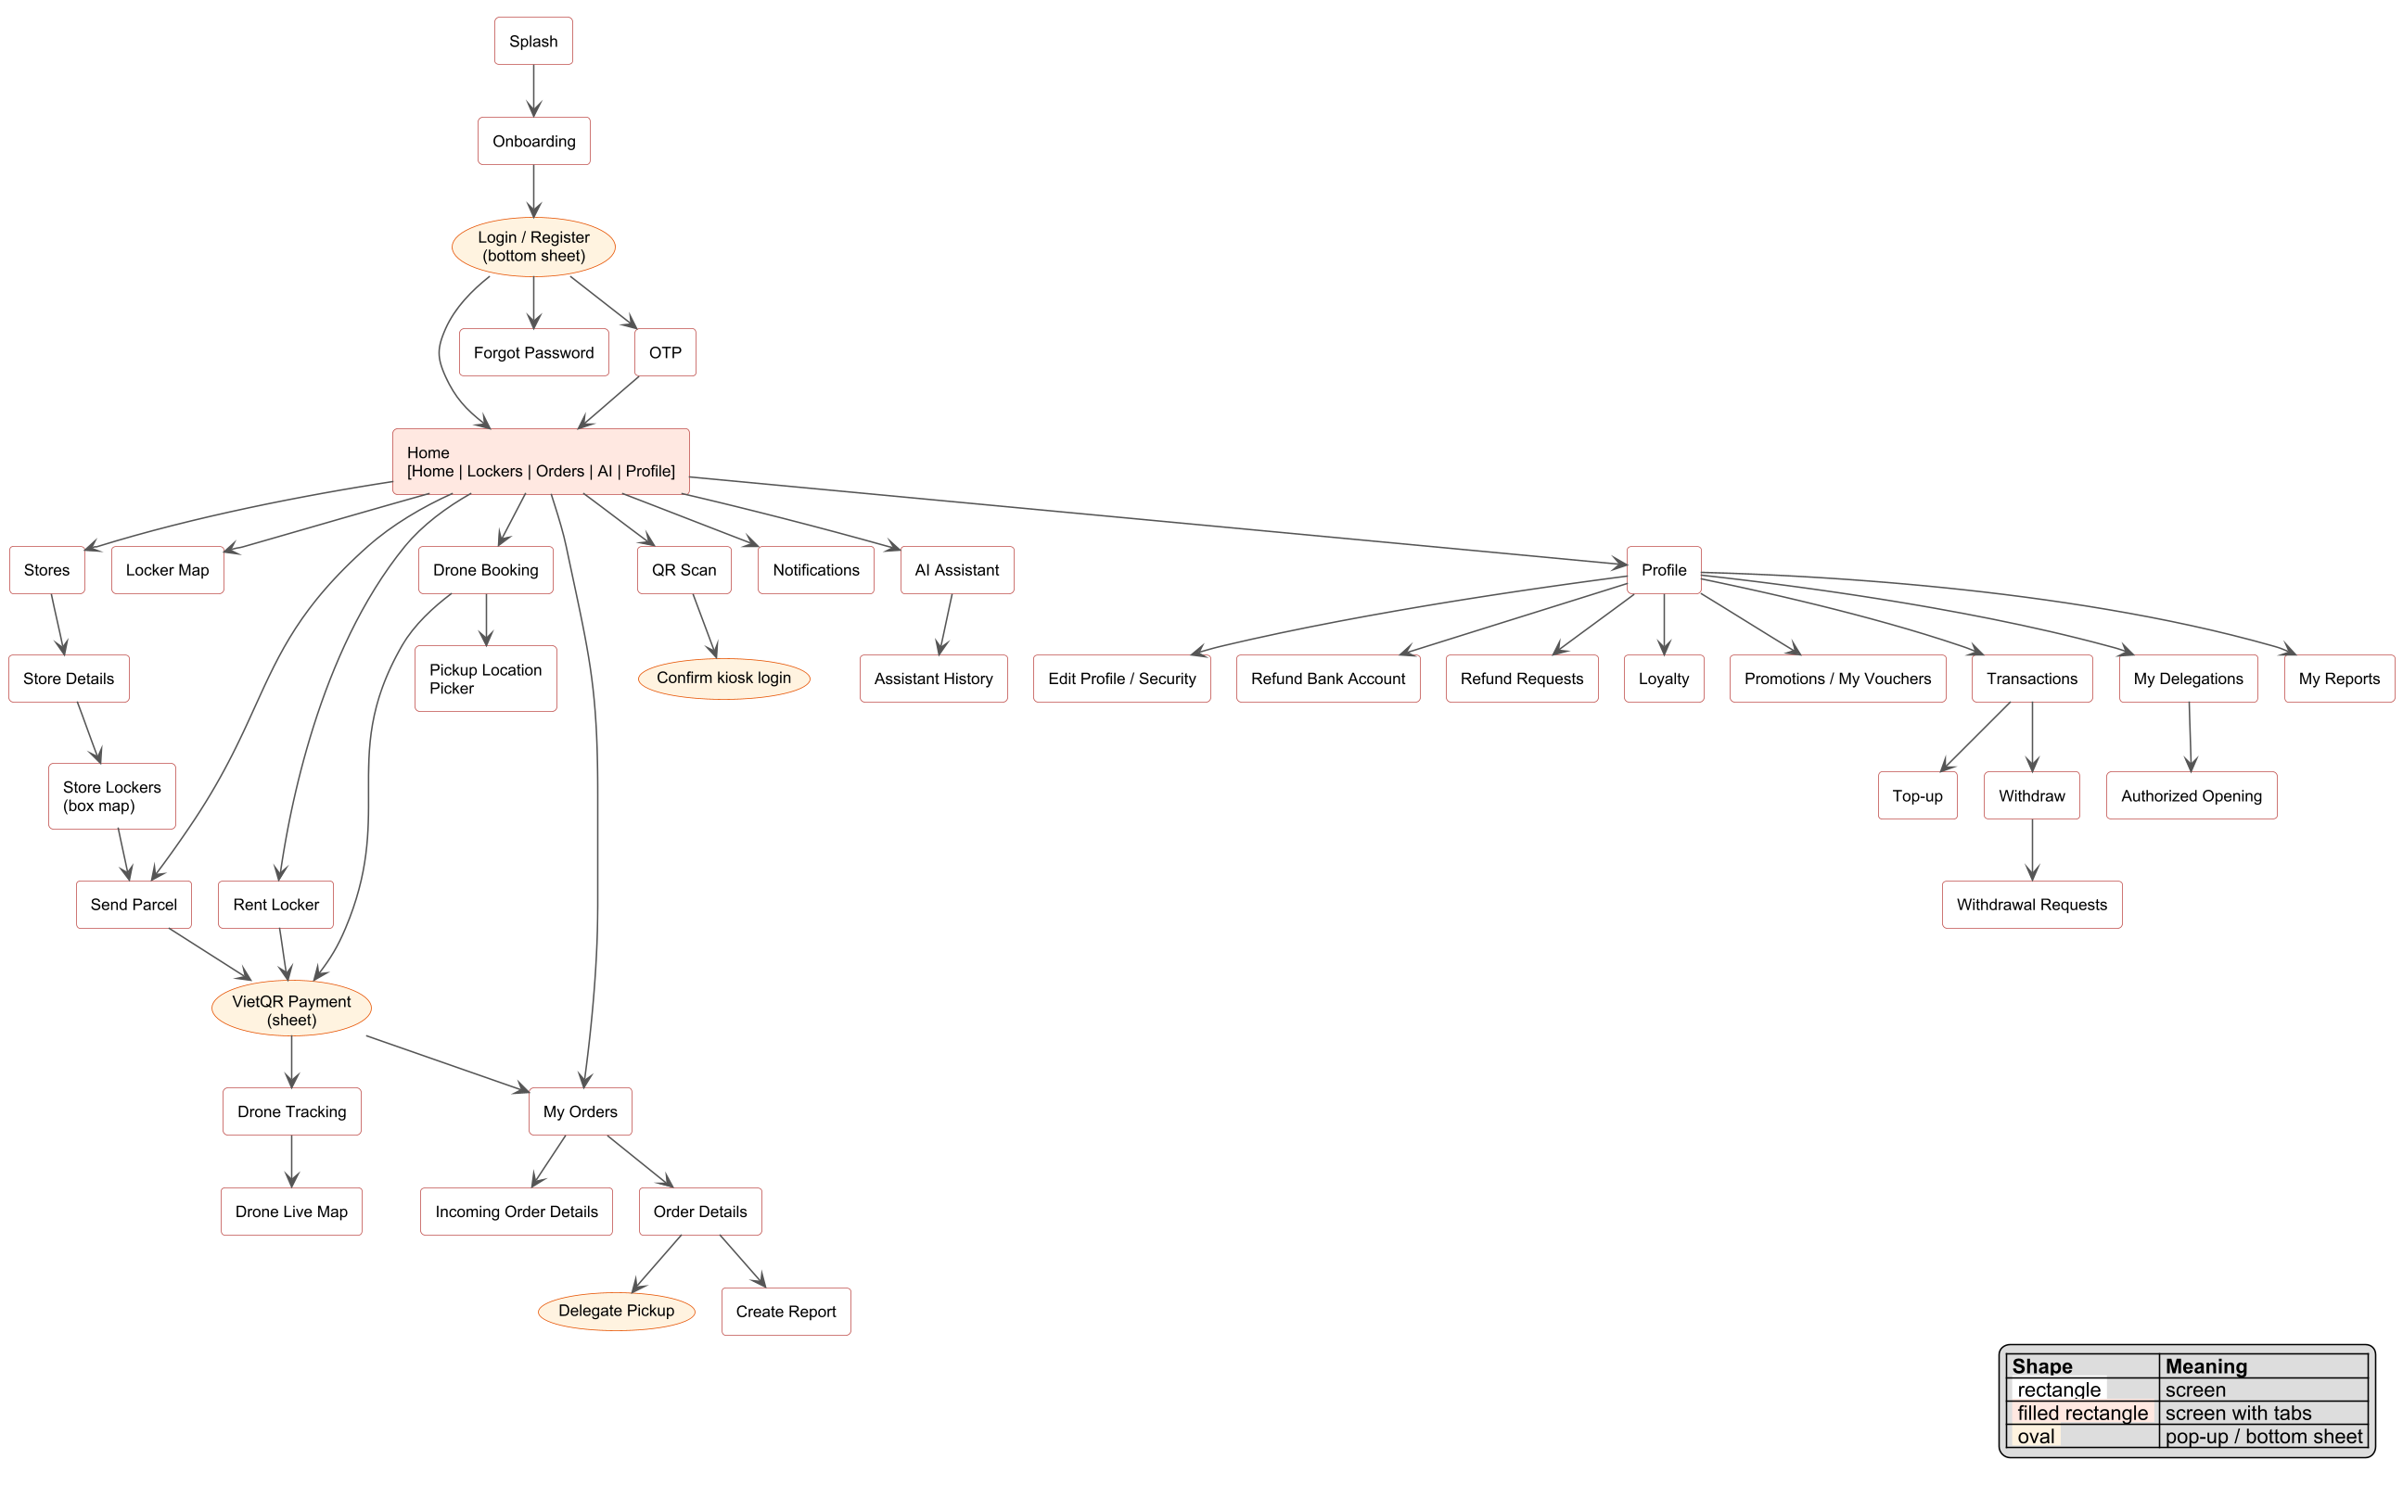
Figure 8. Screens flow - mobile app (customer)
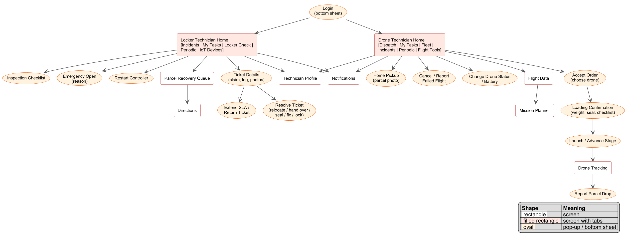
Figure 9. Screens flow - mobile app (locker & drone technicians)

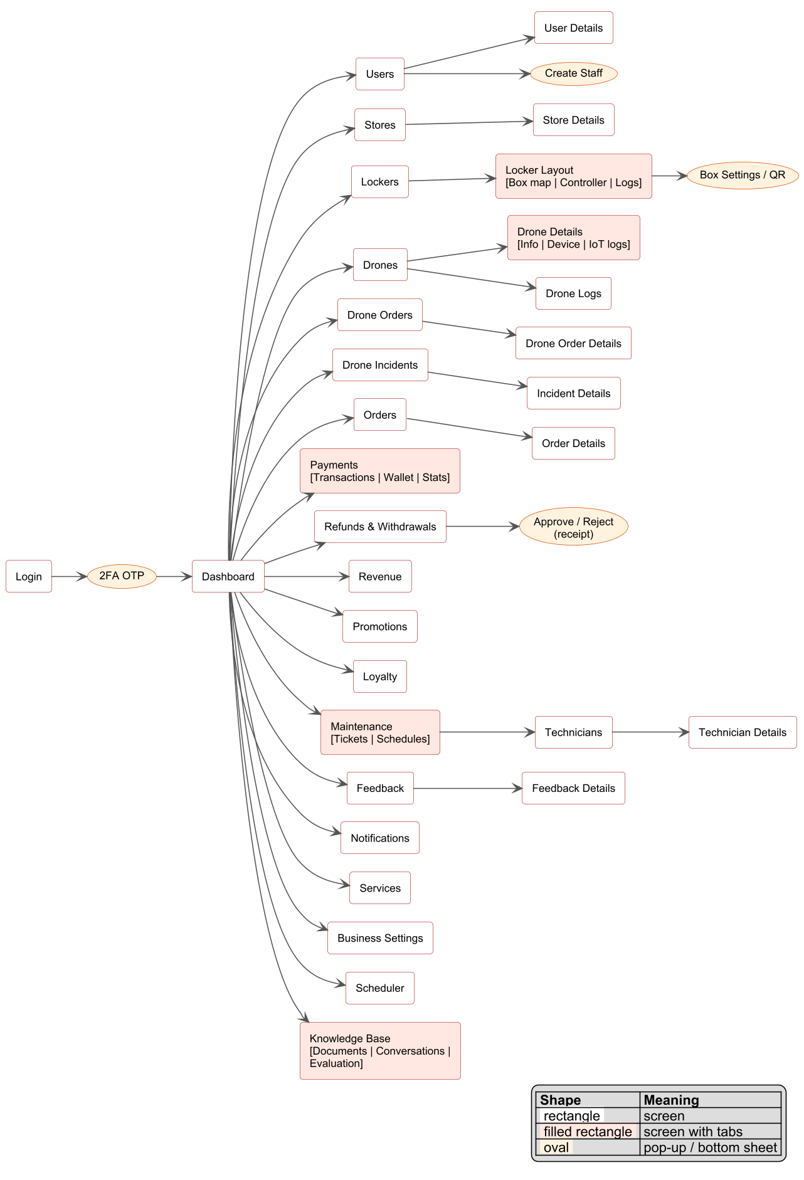
Figure 10. Screens flow - admin web
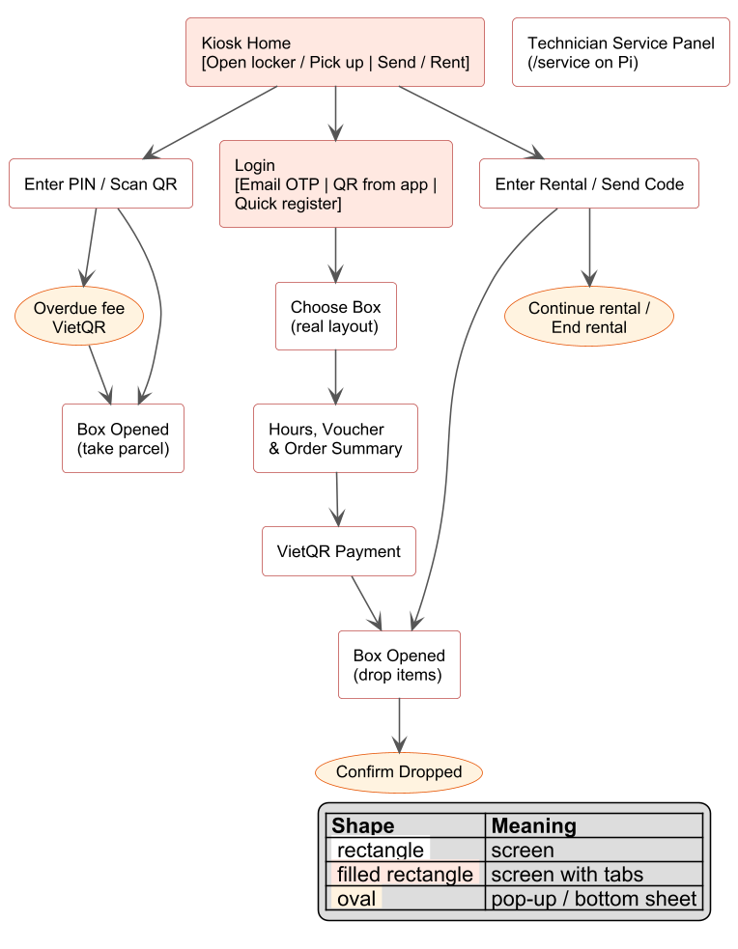
Figure 11. Screens flow - locker kiosk

3.1.2 Screen Descriptions
# | Feature | Screen | Description
1 | Common | Splash & Onboarding | Checks the saved token and opens the home page by role; first-time users see onboarding slides and the location permission request.
2 | Common | Login / Register (bottom sheet) | Tabs Login / Register; email or phone; Google; forgot password link.
3 | Common | OTP | Enter the 6-digit OTP (email or Firebase phone).
4 | Common | Forgot Password | Request an OTP by email and set a new password.
5 | Common | Home | Quick actions (Send parcel, Rent locker, Drone, QR scan), active orders, nearby lockers, wallet balance; bottom navigation Home / Lockers / Orders / AI / Profile.
6 | Common | Notifications | List of notifications; tap opens the related screen; delete one / all.
7 | Common | Profile, Edit Profile, Security | Profile overview, edit personal information and avatar, change password.
8 | Locker | Stores, Store Details, Favorites | Store list with search and favorites, store information, lockers of the store, directions.
9 | Locker | Locker Map | Map of lockers with online / offline status and free boxes.
10 | Locker | Store Lockers (box map) | Real layout of the locker's boxes with status colours; tap a free box to book.
11 | Locker Send | Send Parcel | Form to create a SEND order (locker, size / box, receiver, voucher, points) and the drop steps.
12 | Payment | VietQR Payment (sheet) | Amount, VietQR image, bank / account / transfer content, button to open the bank app; waits for webhook confirmation.
13 | Locker Send | My Orders | Orders grouped by status with filters; tab of incoming orders for receivers.
14 | Locker Send | Order Details | PIN / QR, share, change PIN, delegate, status history, payments, relocation record, report box fault, rate order.
15 | Locker Send | Incoming Order Details | Order sent to the user (as receiver or delegate): sender, locker & box, PIN, timeline.
16 | Locker Send | My Delegations, Authorized Opening | Orders delegated to the user and the screen to open the box remotely.
17 | Locker Rental | Rent Locker | Choose locker, box type, hours, voucher; reopen, extend and end the rental.
18 | Drone Delivery | Drone Booking, Pickup Location Picker | Create a drone order (receiver locker / box, parcel, weight, value, receiver) or a home pickup location.
19 | Drone Delivery | Drone Tracking, Drone Live Map | Stage timeline, A-to-B map, live position, cancel, surcharge banner, pickup photo.
20 | Wallet | Transactions, Top-up, Withdraw, Withdrawal Requests | Wallet balance and history, top-up by VietQR, withdrawal to bank and its status.
21 | Payment | Refund Bank Account, Refund Requests | Bank account for refunds; list and creation of refund requests with evidence.
22 | Promotion | Promotions, My Vouchers, Loyalty | Active promotions, saved vouchers, points, tier and history.
23 | Maintenance | Create Report, My Reports | Report a faulty box / locker with photos; follow the ticket and rate the technician.
24 | AI Assistant | AI Assistant, Assistant History | Chat with cited answers; previous conversations.
25 | Locker Technician | Locker Technician Home | Tabs Incidents / My Tasks / Locker Check / Periodic / IoT Devices with counters and SLA badges.
26 | Locker Technician | Ticket Details, Resolve Ticket, Extend SLA | Claim, progress log, photos, resolution options, SLA extension, return ticket.
27 | Locker Technician | Parcel Recovery Queue, Directions | Tasks to recover dropped drone parcels with GPS check-in and directions.
28 | Technician | Technician Profile | Personal data, shift card, performance and SLA statistics.
29 | Drone Technician | Drone Technician Home | Tabs Dispatch / My Tasks / Fleet / Incidents / Periodic / Flight Tools.
30 | Drone Technician | Accept Order, Home Pickup, Loading Confirmation | Choose drone, confirm pickup with photo, weight / seal / checklist.
31 | Drone Technician | Flight Data, Mission Planner | Telemetry of the drone (position, altitude, GPS, battery, mode) and mission planning.
32 | Kiosk | Kiosk Home | Two entries: Open locker / Pick up and Send / Rent.
33 | Kiosk | Enter PIN / Scan QR | Numeric keypad or camera; messages on wrong code and lock-out; overdue fee payment.
34 | Kiosk | Kiosk Login | Email OTP, QR from app or quick registration.
35 | Kiosk | Choose Box, Order Summary, VietQR Payment | Real box layout, hours, voucher, VietQR; the box opens after payment.
36 | Kiosk | Box Opened, Rental Code | Instructions to drop / take items, confirm dropped, continue or end rental.
37 | Kiosk | Technician Service Panel (/service) | Local page on the Pi to open each box with a custom pulse time and see the 40-pin map.
38 | Admin | Login, 2FA OTP | Email + password, then 6-digit OTP.
39 | Admin | Dashboard | KPIs, revenue chart, orders by status, peak hours, top locations.
40 | Admin | Users, User Details, Create Staff | Search, filters, create technician, lock / unlock, delete.
41 | Admin | Stores, Store Details | CRUD stores.
42 | Admin | Lockers, Locker Layout | CRUD lockers and boxes, box map, GPS, QR printing, technician, controller, connection logs.
43 | Admin | Drones, Drone Details, Drone Logs | CRUD drones, hardware device, status, battery, IoT logs.
44 | Admin | Drone Orders, Drone Order Details | Drone orders with mission record, timeline, map, pickup photo.
45 | Admin | Drone Incidents, Incident Details | Parcel drop incidents: assignment, evidence, resolution.
46 | Admin | Orders, Order Details | All orders with filters, details and history.
47 | Admin | Payments | Transactions, wallet movements, statistics.
48 | Admin | Refunds & Withdrawals | Pending / processed requests, approve with receipt or reject.
49 | Admin | Revenue | Revenue by service, locker and period.
50 | Admin | Promotions, Loyalty | Promotion CRUD and loyalty configuration.
51 | Admin | Maintenance, Technicians | Tickets, schedules, technician list, ranking and details.
52 | Admin | Feedback, Feedback Details | Ratings, complaints, reply, statistics, NPS.
53 | Admin | Notifications | Send / broadcast notifications, statistics.
54 | Admin | Services, Business Settings, Scheduler | Service cards, configurable rules per scope, scheduled jobs.
55 | Admin | Knowledge Base | Documents, conversations, evaluation of the AI assistant.

3.1.3 Screen Authorization
X = the role can use the screen / operation. Access is enforced by the API gateway (JWT + role by path) and by owner checks inside the services.
Screen / Operation | Guest | Customer | Locker Tech. | Drone Tech. | Admin
Landing page, Login, Register, Forgot Password | X | X | X | X | X
Stores, Locker Map, Store Lockers (view) | X | X | X | X
Kiosk Pickup by PIN / QR | X | X
Home (customer), Send Parcel, Rent Locker, Drone Booking |  | X
My Orders, Order Details, Drone Tracking |  | X
Wallet, Refunds, Promotions, Loyalty |  | X
Create Report, My Reports |  | X | X
AI Assistant |  | X | X | X
Notifications, Profile |  | X | X | X
Locker Technician Home, Ticket handling, Emergency Open, IoT Devices |  |  | X
Parcel Recovery Queue |  |  | X
Drone Technician Home, Dispatch, Loading, Launch, Fleet |  |  |  | X
Periodic Inspection |  |  | X | X
Admin web (all screens) |  |  |  |  | X
Query All Data |  |  |  |  | X
Query Own Data (orders, wallet, notifications, profile) |  | X | X | X | X
Query Managed Data (tickets / drones assigned to me) |  |  | X | X
Add New Data (orders, reports, refund requests) |  | X | X | X | X
Update Own Data |  | X | X | X | X
Update Managed Data (claimed tickets / drones) |  |  | X | X | X
Update All Data (settings, roles, lockers, drones) |  |  |  |  | X
Delete Data (users, lockers, boxes, tickets) |  |  |  |  | X

3.1.4 Non-Screen Functions
# | Feature | System Function | Description
1 | Order | Auto-cancel unconfirmed orders | order-service job every 2 minutes: cancels orders unpaid after 15 minutes / not dropped after 24 hours and releases their boxes.
2 | Order | Overdue pickup reminder | Job every 10 minutes: reminds senders / receivers of overdue parcels, at most once per 60 minutes.
3 | Order | Release overdue orders | Hourly job: orders overdue longer than 72 hours become EXPIRED (moved to warehouse) and the box is released.
4 | Order | Reconcile box states | Hourly job: compares box status in locker-service with active orders and fixes differences; nightly 03:15 release of boxes held by completed orders.
5 | Loyalty | Retry point refunds | Job every 10 minutes: returns loyalty points of cancelled / refunded orders when loyalty-service was unavailable (idempotent).
6 | Drone Delivery | Drone order timeouts | Job every 5 minutes: cancels and refunds drone orders unpaid after 30 minutes, not dispatched / launched in time or with unpaid surcharge after 60 minutes.
7 | Drone Delivery | Home pickup dispatch | Job every 30 seconds: opens pickup offers for paid home-pickup orders to the nearest on-duty drone technicians (offer valid 180 s).
8 | Drone Delivery | Blocked delivery review | Job every minute: for drone orders blocked (no drone / pad / battery) tries an alternative drone; if the block expires the order fails and is refunded.
9 | Drone Delivery | DEMO flight simulator | Moves DEMO drone orders through the flight stages every 3 seconds and broadcasts interpolated positions over STOMP.
10 | Drone Delivery | Drone telemetry listener | Subscribes to lockr/drones/+/telemetry over MQTT, verifies the HMAC signature and freshness and advances STANDARD orders by real position.
11 | Drone Delivery | Drone-locker communication | Exchanges ArUco landing / compartment messages between drone and locker and logs every message (drone_locker_comm_logs).
12 | Locker | Expired reservation sweep | Hourly backstop that releases boxes still RESERVED after their hold time (24 h).
13 | Maintenance | Inspection schedule reminder | Daily at 07:00 (Vietnam time): notifies technicians of inspections due within 24 hours.
14 | IoT | MQTT locker bridge | iot-service subscribes to cabinet/{lockerId} topics: sends open / restart commands with boxId + slotIndex, waits up to 20 s for the ack, records door states and access logs.
15 | IoT | Controller disconnection log | Job every 60 seconds: a controller without heartbeat is logged as disconnected once; a new heartbeat logs reconnection.
16 | Payment | SePay webhook | POST /api/payments/sepay/webhook: verifies the API key, matches the transfer content with the order code, records the received amount and publishes payment events (duplicates ignored).
17 | Payment | Payment event listener | order-service consumes payment events from RabbitMQ and marks the order PAID only when the paid amount covers the total.
18 | Loyalty | Order completed listener | loyalty-service consumes order.completed events and adds points (1 point per 1,000 VND paid).
19 | Notification | Notification dispatcher | notification-service consumes notification events and sends FCM push, in-app (STOMP /ws), email and SMS (eSMS / Twilio).
20 | Authentication | Kiosk QR session cleanup | Job every 30 seconds: removes expired kiosk QR login sessions.
21 | AI Assistant | Knowledge indexer | Job every 5 seconds: splits PENDING documents into chunks (~2,000 characters, overlap 200), creates Voyage embeddings and marks them READY / FAILED.
22 | Security | API gateway filter | Validates the JWT access token, blocks accounts that are no longer ACTIVE and applies role-based access by path before routing to services.
23 | Media | Signed media upload | user-service issues Cloudinary upload signatures; services verify the returned signature before saving image URLs.

3.1.5 Entity Relationship Diagram
Each microservice owns its database. Solid lines are foreign keys inside one database; dashed lines are logical references by id between services.
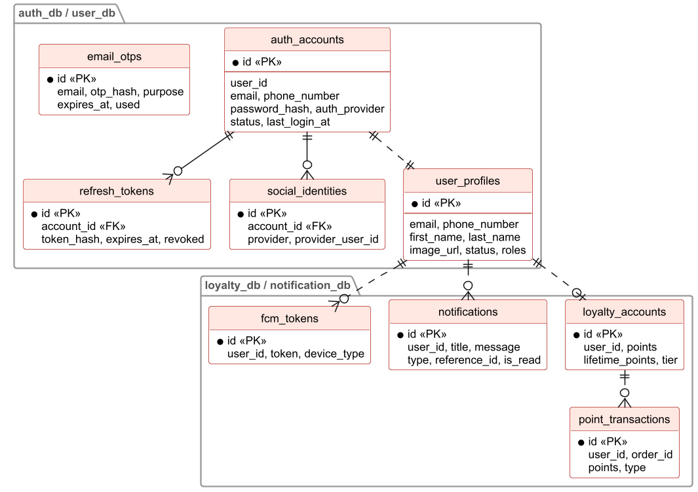
Figure 12. ERD - accounts, loyalty & notifications

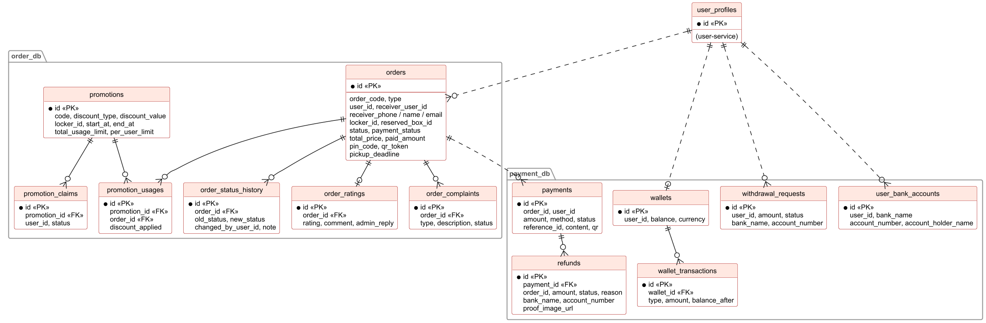
Figure 13. ERD - orders, promotions & payments

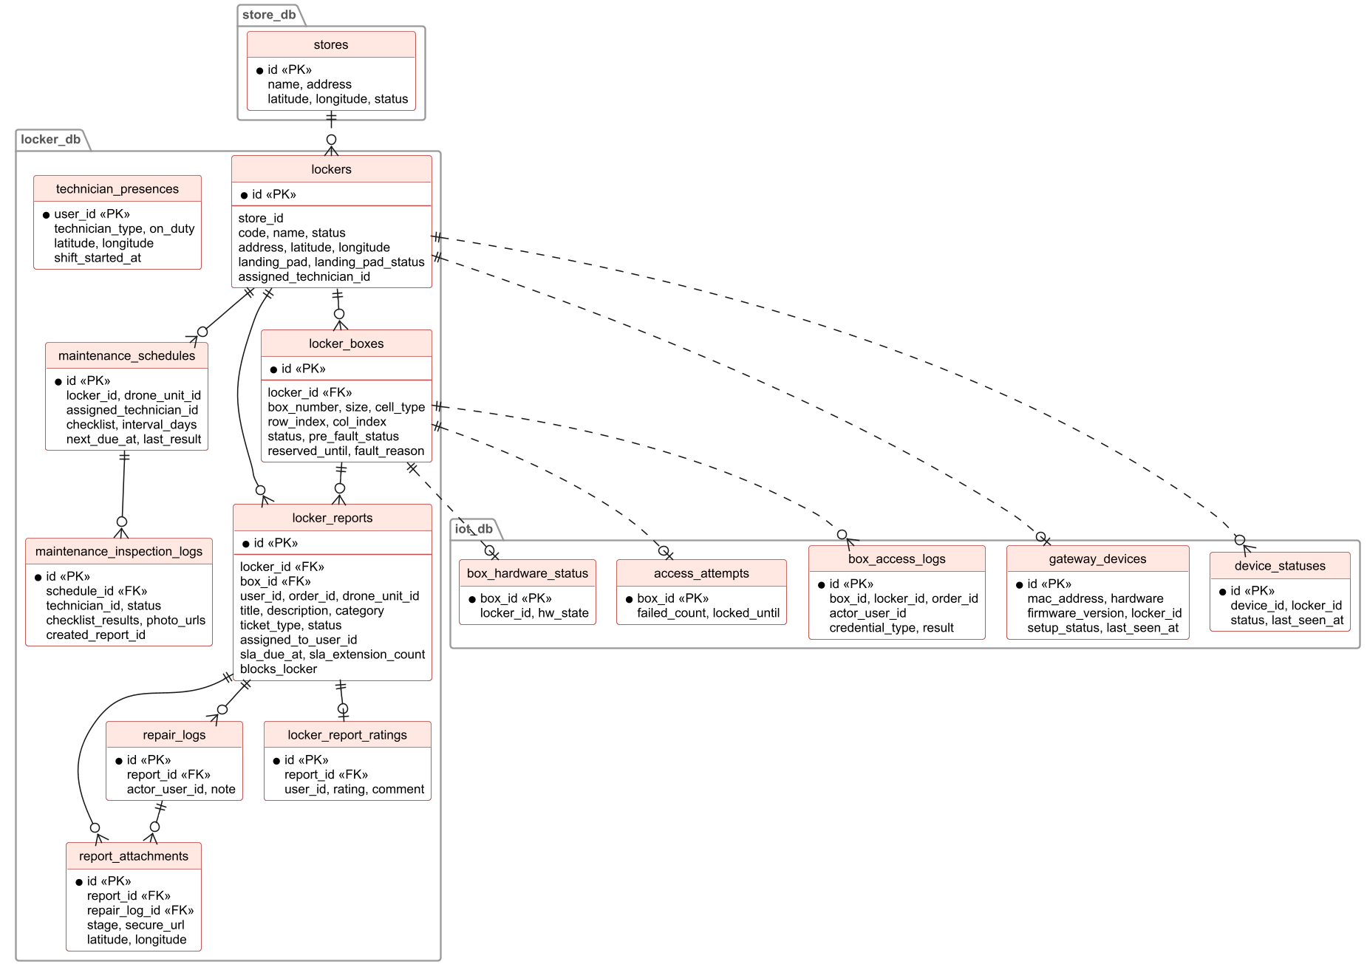
Figure 14. ERD - stores, lockers, maintenance & IoT
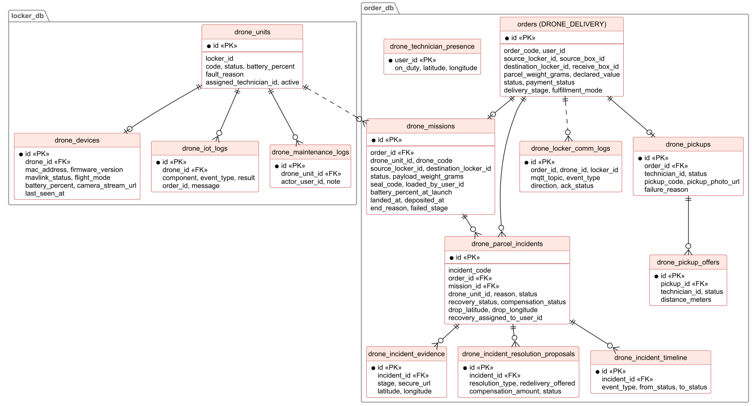
Figure 15. ERD - drone fleet, missions & incidents
Entities Description
# | Entity | Description
1 | auth_accounts | Login credentials of a user: email, phone, password hash, provider (LOCAL / GOOGLE / PHONE), status, last login.
2 | refresh_tokens / email_otps / social_identities | Refresh tokens (hashed, revocable), one-time passwords for login / reset / 2FA, linked Google / Firebase identities.
3 | user_profiles | Profile of a user: name, email, phone, avatar, roles (CUSTOMER, LOCKER_TECHNICIAN, DRONE_TECHNICIAN, ADMIN) and status.
4 | stores | Location (store) that hosts lockers: name, address, coordinates, status.
5 | lockers | Locker cabinet: code, store, address, GPS, status (ACTIVE / MAINTENANCE / OFFLINE), landing pad and responsible technician.
6 | locker_boxes | Box of a locker: number, size, cell type (STANDARD / XL / DRONE), grid position, status (AVAILABLE / RESERVED / OCCUPIED / FAULT), hold time, ArUco marker.
7 | locker_reports | Ticket for a box, locker or drone: category, status (OPEN / IN_PROGRESS / RESOLVED), assignee, SLA due time and extensions.
8 | repair_logs / report_attachments / locker_report_ratings | Progress notes, photos (before / during / after, GPS) and the reporter's rating of a ticket.
9 | maintenance_schedules / maintenance_inspection_logs | Periodic inspection plans with checklist and interval, and each inspection result.
10 | technician_presences / drone_technician_presence | Shift state and last location of technicians.
11 | gateway_devices / device_statuses | Raspberry Pi controllers (MAC, firmware, assigned locker, last seen) and device online status.
12 | box_hardware_status / box_access_logs / access_attempts | Door state of each box, every open attempt with credential and result, wrong-PIN counter and lock-out.
13 | orders | Order of type SEND, RENTAL, STORAGE or DRONE_DELIVERY: code, customer, receiver, lockers and boxes, status, payment status, total and paid amount, PIN / QR, deadlines, delivery stage.
14 | order_status_history | Every status change of an order with actor and note.
15 | order_ratings / order_complaints | Customer ratings with admin reply, and complaints.
16 | promotions / promotion_claims / promotion_usages | Promotion definition (code, discount, period, limits, locker scope), vouchers saved by users and their use on orders.
17 | drone_units / drone_devices / drone_iot_logs / drone_maintenance_logs | Drone fleet, the hardware device on each drone, its IoT events and maintenance notes.
18 | drone_missions | One flight of a drone order: drone, route, loading data (weight, seal code, checklist), launch, landing and end reason.
19 | drone_pickups / drone_pickup_offers | Home pickup of a drone order and the offers sent to drone technicians.
20 | drone_parcel_incidents / drone_incident_evidence / drone_incident_resolution_proposals / drone_incident_timeline | Parcel drop incident, its evidence, the redelivery / compensation proposal and the event timeline.
21 | drone_locker_comm_logs | MQTT messages exchanged between drones and lockers.
22 | payments / refunds | Payment attempts (method, amount, status, VietQR content) and refund requests with bank account and receipt.
23 | wallets / wallet_transactions / withdrawal_requests / user_bank_accounts | Wallet balance and ledger, withdrawal requests and saved bank accounts.
24 | loyalty_accounts / point_transactions | Points, lifetime points and tier of a user, and every earn / redeem / reversal.
25 | notifications / fcm_tokens | In-app notifications and device push tokens.
26 | kb_documents / kb_chunks / assistant_conversations / assistant_messages | AI assistant knowledge base (documents, embedded chunks, allowed roles) and chat history with citations.
27 | system_settings / system_setting_audits | Configurable business rules of each service and the audit trail of changes.

3.2 Account & Authentication

3.2.1 Log in / Register
Function trigger
Mobile app: Splash -> Onboarding -> 'Đăng nhập / Đăng ký' bottom sheet, or any protected action when the user is not logged in.
Function description
Actors: Guest. Lets a guest create a CUSTOMER account or log in by email / password, Google or phone OTP. After login the app routes by role: Customer home, Locker Technician home, Drone Technician home; ADMIN accounts are told to use the admin web.
Screen layout
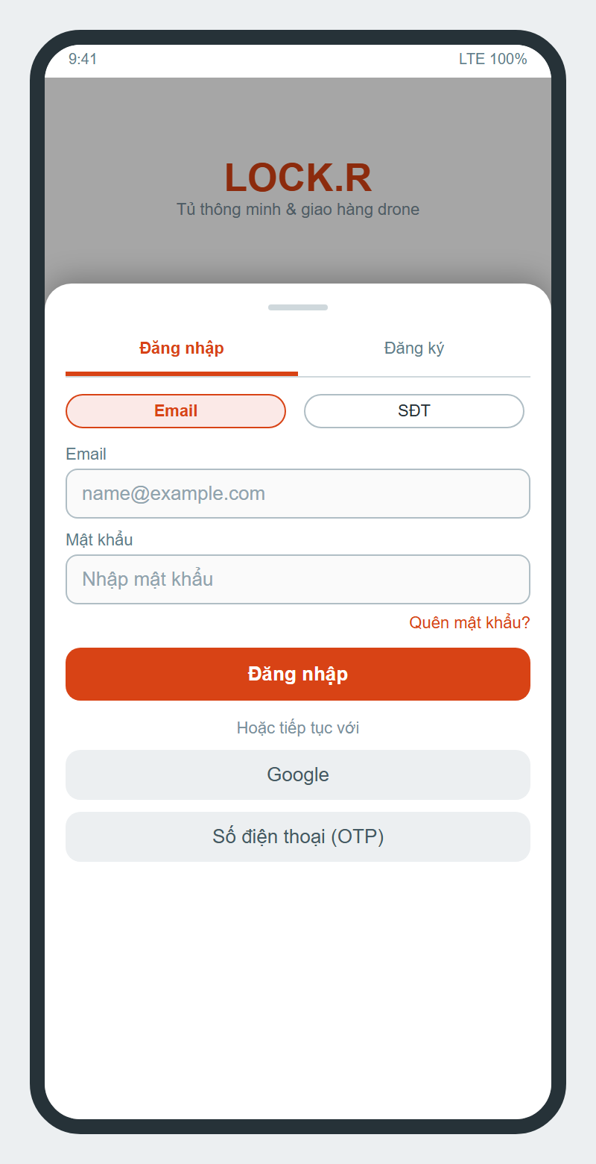
Figure 16. Login / Register bottom sheet
Function details
- Register fields: full name (2-50 characters), email (valid format, unique), phone (10-15 digits, unique), password (6-20 characters), confirm password, accept terms of use.
- Phone login: Firebase sends the SMS OTP; the server only accepts a verified Firebase ID token. A first-time phone user must complete registration (full name) with a temporary token valid 600 s.
- Google login creates or links an account by verified email (social identity).
- Wrong credentials show 'Thông tin đăng nhập không hợp lệ'. Locked / deleted accounts cannot log in; a locked account loses access within about 30 s because the gateway checks the account status.
- The server returns an access token (JWT) and a refresh token; refresh tokens are stored hashed and revoked on logout or lock.
- Logout also unregisters the device push token.

3.2.2 Reset Password
Function trigger
Login sheet -> 'Quên mật khẩu?'.
Function description
Actors: Guest. Resets a forgotten password through an email OTP.
Function details
- The user enters the registered email; the system sends a 6-digit OTP valid 300 s (length and expiry configurable).
- The OTP is stored hashed and can be used once; OTP values are never written to logs.
- After a valid OTP the user sets a new password (6-20 characters, confirmed).

3.2.3 Kiosk QR Login
Function trigger
Kiosk -> 'Gửi đồ / Thuê tủ' -> 'Quét QR bằng app'; app Home -> QR button.
Function description
Actors: Customer. Logs the customer in at the kiosk without typing credentials.
Function details
- The kiosk requests a one-time login QR that expires after 2 minutes; too many requests show 'Tạo mã quá nhiều lần. Vui lòng thử lại sau ít phút.'
- The app scans the QR (or the user types the code) and asks 'Đăng nhập kiosk?'; on confirm the kiosk receives the session and shows the customer's name.
- Expired sessions are cleaned every 30 s. Alternative: email OTP directly on the kiosk, or quick registration.

3.2.4 Admin Login with 2FA
Function trigger
Admin web https://admin.locker-drone.tech -> Login.
Function description
Actors: Administrator. Two-step login to the admin web.
Function details
- Step 1: email + password of an ADMIN account. Step 2: 6-digit OTP sent by email; at most 5 wrong attempts.
- Non-admin accounts are rejected. Every /api/admin/** call requires the ADMIN role at the gateway.
- Token refresh keeps the admin logged in; logout clears tokens.

3.2.5 Home Page
Function trigger
Successful customer login; bottom navigation 'Trang chủ'.
Function description
Actors: Customer. Entry point to all customer functions.
Screen layout
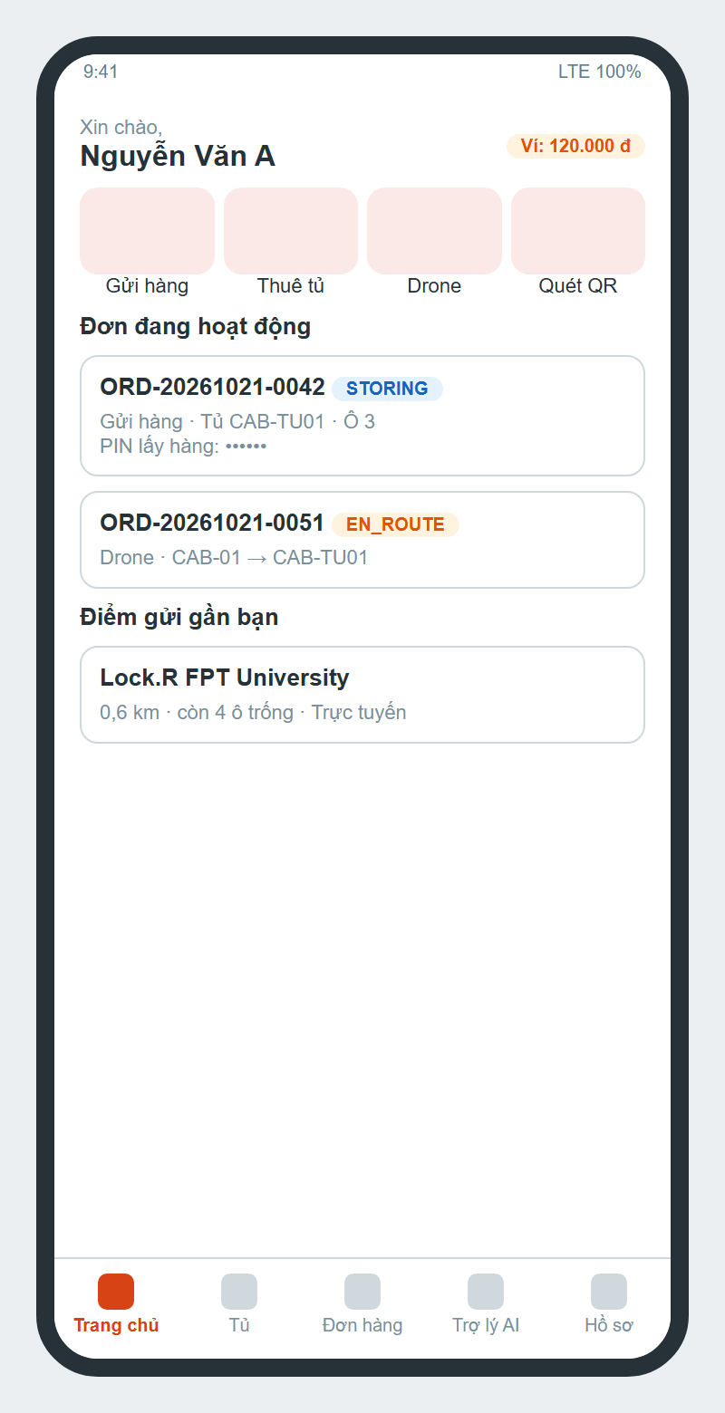
Figure 17. Customer home page
Function details
- Shows greeting, wallet balance, quick actions Send parcel / Rent locker / Drone / Scan QR.
- Lists active orders with status badge and nearby lockers with distance, free boxes and online status.
- Bottom navigation: Home, Lockers, Orders, AI Assistant, Profile. Badge on the bell icon shows unread notifications.

3.3 Locker Send

3.3.1 Send Parcel
Function trigger
Home -> 'Gửi hàng', or tap a free box on the locker map.
Function description
Actors: Customer. Creates a SEND order and reserves a box for the parcel.
Screen layout
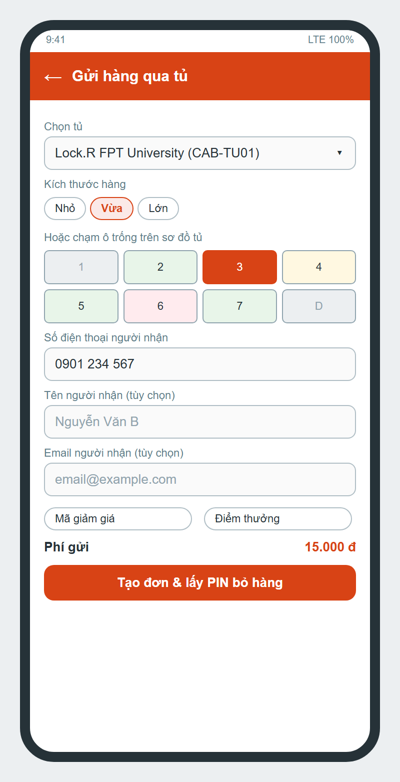
Figure 18. Send Parcel
Function details
- Inputs: locker (required, must be ACTIVE and online), parcel size Small / Medium / Large or a free box on the map, receiver phone (required, valid VN phone), receiver name and email (optional, email validated), voucher, use loyalty points.
- Fee = send base fee (default 15,000 VND) minus voucher, then minus points (max 50 % of the order, 1 point = 100 VND, min 10 points).
- On 'Tạo đơn & lấy PIN bỏ hàng' the system creates the order (INITIALIZED, UNPAID) and reserves the box (RESERVED).
- If the user leaves before paying the app asks 'Hủy tạo đơn hàng?' (Cancel order & exit / Stay to pay). Unpaid orders are cancelled automatically after 15 minutes and the box is released.
- Lockers in MAINTENANCE or offline cannot be booked; if no box of the size is free the user is asked to choose another locker.

3.3.2 Pay Order by VietQR
Function trigger
Right after creating a SEND / RENTAL / DRONE order, or 'Thanh toán' on an unpaid order.
Function description
Actors: Customer. Pays the order by bank transfer through SePay.
Screen layout
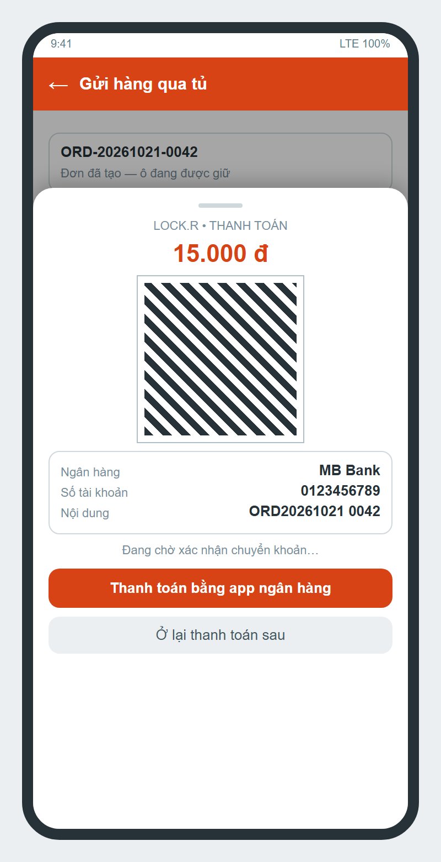
Figure 19. VietQR payment sheet
Function details
- The server generates the VietQR (bank, account number, amount, transfer content containing the order code); the app can open the bank app pre-filled.
- SePay calls the webhook; the payment is matched by order code, the received amount is added to paid_amount and the order becomes PAID only when the total is covered. Duplicate webhooks are ignored.
- Money arriving after the order was cancelled is refunded automatically.
- Enabled methods are configured by admin (default SEPAY only); MoMo, VNPay and cash were removed. A test 'simulate payment' button appears only when the admin enables payment simulation.
- On success the app shows the success animation and the order details; while waiting it shows 'Đang chờ xác nhận chuyển khoản…'.

3.3.3 Drop Parcel
Function trigger
Order details -> 'Mở ô để bỏ hàng', or enter the send code at the kiosk.
Function description
Actors: Customer, Locker controller. Opens the reserved box so the sender can put the parcel in.
Function details
- Payment before drop is required (configurable). The box can be opened only for a PAID order; otherwise 'ORDER_UNPAID'.
- The open command is sent over MQTT; the controller has 20 s to answer and the door stays open 15 s.
- 'Tôi đã bỏ hàng vào ô' is accepted only after the box was opened. Then the box becomes OCCUPIED and the order STORING.
- The receiver gets the pickup code by SMS / email (if enabled) and in the app when the phone / email belongs to an account.

3.3.4 Share Code, Change PIN & Delegate Pickup
Function trigger
Order details of a STORING order.
Function description
Actors: Customer. Lets the sender share, renew or delegate the pickup code.
Screen layout
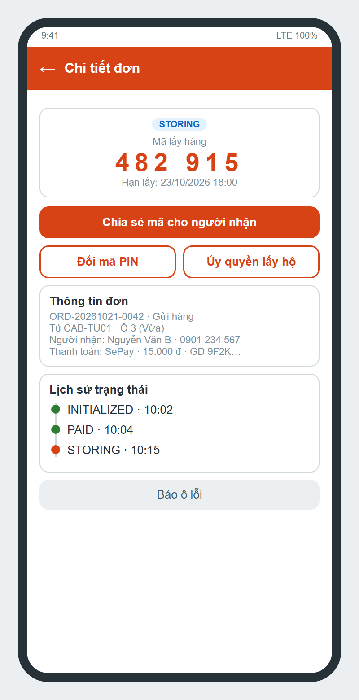
Figure 20. Order details with pickup code
Function details
- Share: system share sheet (Zalo, Messenger, SMS) with PIN, QR, locker address and deadline.
- Change PIN: generates a new 6-digit PIN; the old PIN stops working immediately.
- Delegate: enter delegate phone, name and note; the PIN is regenerated and the delegate (if registered) is notified and sees the order in 'Đơn ủy quyền'. The original receiver can no longer use the old code.
- Order details also show status history, payments (method, transaction id), locker and box, relocation record and actions 'Báo ô lỗi', rating.

3.3.5 Pick up Parcel at Kiosk
Function trigger
Kiosk Home -> 'Mở tủ / Nhận đồ'; or BLE one-tap in the app near the locker.
Function description
Actors: Receiver, Locker controller. Opens the box with the pickup code and completes the order.
Screen layout
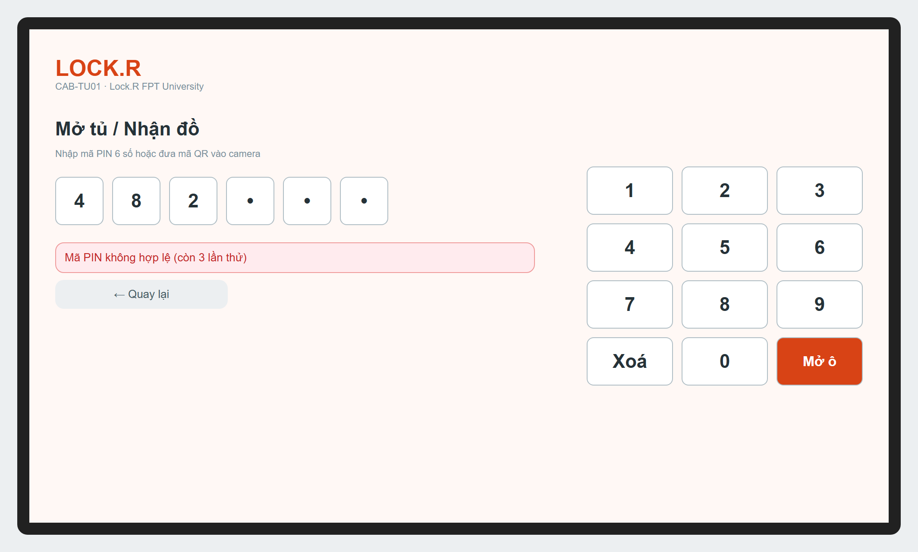
Figure 21. Kiosk - enter PIN
Function details
- Input: 6-digit PIN by keypad or QR token by camera. No account is needed (public endpoint).
- Wrong code shows 'Mã PIN không hợp lệ'; after 5 wrong attempts the box is locked for 15 minutes: 'Nhập sai quá số lần cho phép! Thao tác bị tạm khóa…'.
- If the pickup deadline (48 h for SEND) has passed, the receiver must pay the overtime fee (500 VND / hour, max 50,000 VND and 50 % of the order, 15 minutes grace) by VietQR before the box opens.
- On success the box opens, the order becomes COMPLETED, the box is released and the sender earns loyalty points.
- BLE: the app detects the locker's beacon and opens the box of the user's order in one tap.

3.4 Locker Rental

3.4.1 Rent Locker
Function trigger
Home -> 'Thuê tủ', or kiosk -> 'Gửi đồ / Thuê tủ'.
Function description
Actors: Customer. Rents a box by the hour to store personal items.
Screen layout
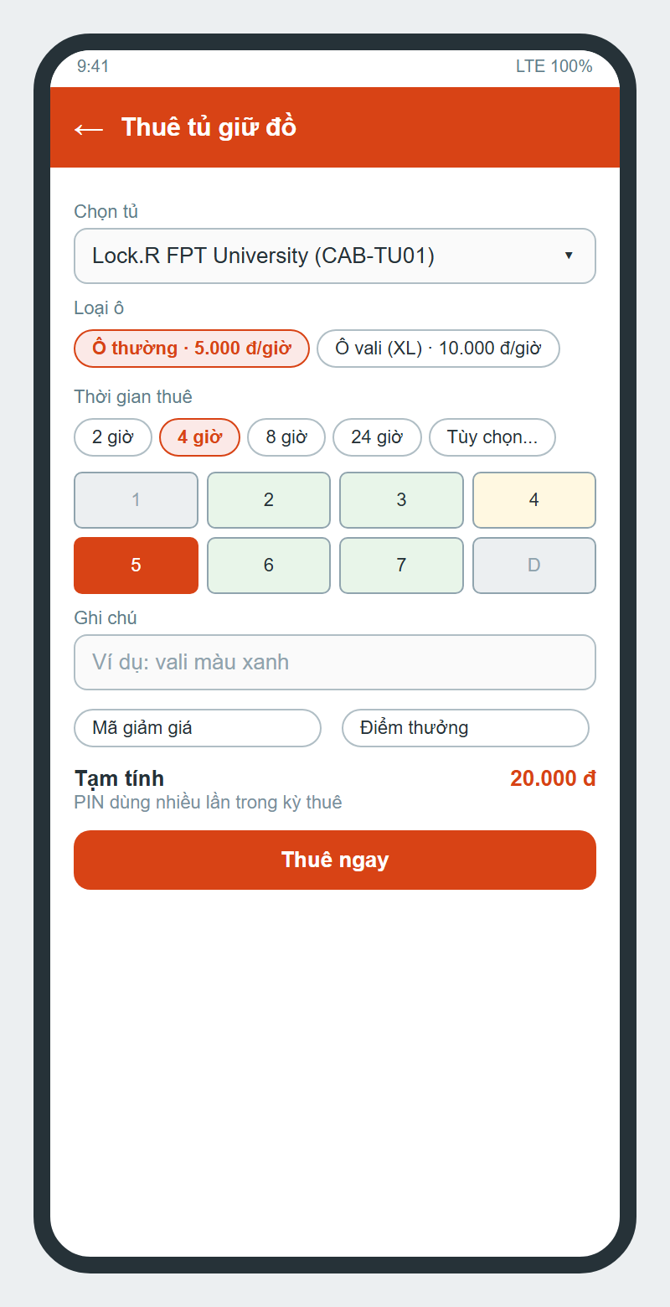
Figure 22. Rent Locker
Function details
- Inputs: locker, box type (Standard 5,000 VND/h, XL 10,000 VND/h), hours (1-720, default 4, quick buttons), note, voucher, points.
- 'Thuê ngay' reserves the box and opens the payment; after payment 'Mở ô để bỏ đồ' -> put items -> 'Bắt đầu kỳ thuê' -> order STORING.
- During the rental the PIN can open the box many times; opening does not end the rental.

3.4.2 Extend / End Rental & Overdue Fee
Function trigger
Order details of a STORING rental, or rental code at the kiosk.
Function description
Actors: Customer. Extends or ends the rental and settles overtime.
Function details
- Extend: up to 24 h per time (default 2 h); only the extra hours are charged (paid amount is kept).
- End: 'Kết thúc thuê & lấy đồ' opens the box a last time; 'Đã lấy đồ và đóng tủ' completes the order and releases the box.
- After the end time, opening requires paying overtime at 100 % of the hourly rental rate; the kiosk shows the amount and VietQR.
- Rentals overdue longer than the release time may be moved to the warehouse when auto-release is enabled (default off).

3.5 Drone Delivery

3.5.1 Book Drone Delivery
Function trigger
Tap a DRONE box at the sender locker -> 'Gửi hàng bằng Drone', or Home -> Drone.
Function description
Actors: Customer. Creates a DRONE_DELIVERY order between two lockers with landing pads.
Screen layout
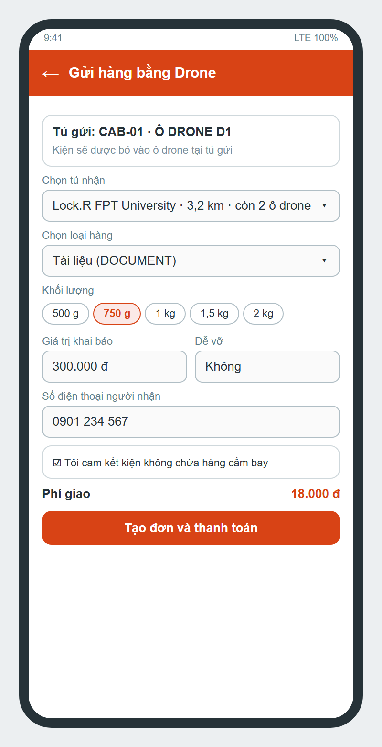
Figure 23. Drone booking
Function details
- Receiver locker must have a landing pad, a free DRONE box and be within 5,000 m; the sheet shows 'còn N ô drone' and blocks lockers that are full.
- Parcel: type (DOCUMENT, FOOD, CLOTHING, ELECTRONICS, COSMETICS, OTHER), weight level (500 / 750 / 1,000 / 1,500 / 2,000 / 3,000 g, max payload 5,000 g), optional size within 30 x 25 x 20 cm, declared value up to 2,000,000 VND, fragile flag, receiver phone / name / email.
- The prohibited-goods commitment is mandatory: 'Bạn cần cam kết kiện không chứa hàng cấm bay'.
- Fee = 15,000 VND (includes 500 g) + 3,000 VND for each started 250 g step above 500 g.
- A customer may have at most 3 open drone orders; booking is refused while admin suspends flights.
- After creation the payment sheet opens; unpaid drone orders are cancelled after 30 minutes.

3.5.2 Track Drone Delivery
Function trigger
Order details of a drone order; push notification of a stage.
Function description
Actors: Customer, Receiver. Follows the delivery in near real time.
Screen layout
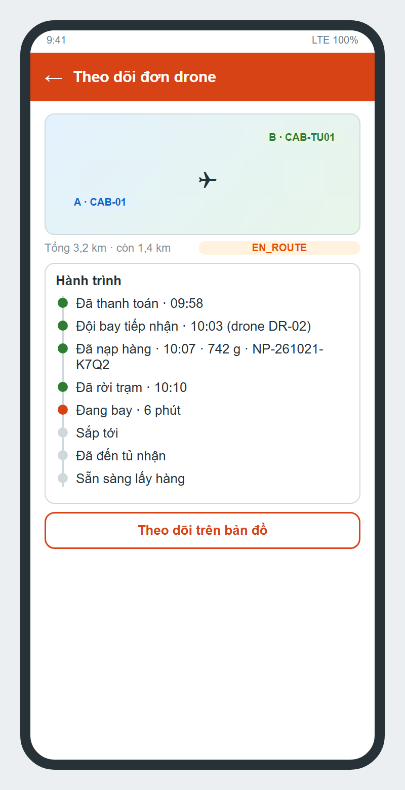
Figure 24. Drone tracking
Function details
- Stages: AWAITING_DISPATCH -> LAUNCHING -> DEPARTED -> EN_ROUTE -> APPROACHING -> ARRIVED -> READY_FOR_PICKUP, each with the time reached and the time spent.
- Map card A -> B with total / remaining distance; 'Theo dõi trên bản đồ' opens the live map fed by STOMP /topic/deliveries/{orderId}/position (DEMO interpolated, real drones from telemetry).
- While awaiting dispatch the customer can cancel ('Huỷ đơn'); a paid order goes to REFUND_PENDING.
- If loading found a weight difference, a banner asks to pay the surcharge or decline (cancel and refund).

3.5.3 Dispatch & Loading Confirmation
Function trigger
Drone Technician Home -> tab 'Điều phối' -> 'Tiếp nhận'.
Function description
Actors: Drone Technician. Assigns a drone to the order and records the loaded parcel.
Screen layout
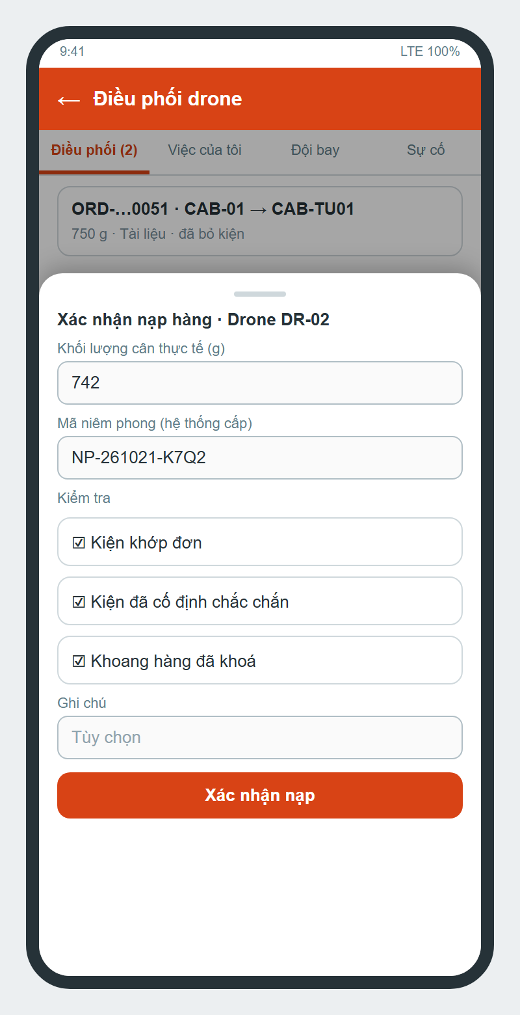
Figure 25. Loading confirmation
Function details
- Accept requires: order PAID, parcel dropped (or picked up), an idle drone at the source locker with battery >= 20 %. The order and the drone are locked so two technicians cannot accept the same order; the drone becomes RESERVED.
- Loading: measured weight (g), system-generated seal code NP-<yyMMdd>-<6 characters>, checklist (parcel matched, payload secured, compartment locked), optional note.
- Weight above declared + 50 g: the fee is recalculated, the order returns to UNPAID until the customer pays the difference (60 minutes) or declines.
- The mission moves AWAITING_LOADING -> READY_TO_LAUNCH only when loading is complete.

3.5.4 Launch & Flight Stages
Function trigger
Mission READY_TO_LAUNCH -> 'Phóng'.
Function description
Actors: Drone Technician, System. Starts the flight and moves the order through stages.
Function details
- Launch is allowed within the configured flight hours and when flights are not suspended; battery and landing pad are re-checked.
- DEMO orders advance automatically (3 s per stage). STANDARD orders advance from signed telemetry (position inside the receiver locker zone) or by the dispatcher confirming each stage.
- At the last stage the parcel is placed in the receiver's DRONE box (OCCUPIED), a 6-digit PIN valid 24 h is created and sent to the receiver by app / email / SMS, the drone returns to IDLE.
- The receiver opens the box at the kiosk; the customer confirms 'Tôi đã lấy đồ — hoàn tất'.

3.5.5 Cancel, Failed Flight & Refund
Function trigger
Customer cancel, technician cancel before launch, 'Báo chuyến bay thất bại', or a timeout job.
Function description
Actors: Customer, Drone Technician, Administrator, System. Stops a drone order and refunds the customer.
Function details
- Failed flight requires a reason; the drone becomes FAULT and a drone ticket is opened; the mission record (weight, seal, end reason, failed stage) is kept.
- Paid orders go to REFUND_PENDING; the admin transfers the money to the customer's bank account and attaches the receipt (or rejects with a reason) -> REFUNDED.
- A refund of 0 VND never closes the order; the order stays PAID with a note for the admin.
- If the parcel already entered the system the order shows where it is held (source box or flight team) until it is returned.

3.5.6 Drone Home Pickup
Function trigger
Drone booking with a pickup location; technician pickup offer notification.
Function description
Actors: Customer, Drone Technician. Collects the parcel at the customer's location instead of a locker.
Function details
- Pickup location within 5,000 m. After payment the system offers the pickup to on-duty technicians nearest first; each offer is valid 180 s.
- The technician must arrive within 60 minutes and confirm pickup with a mandatory parcel photo; then the drone must launch within 120 minutes.
- If no one accepts or the technician fails, the order fails with a reason and is refunded.

3.5.7 Parcel Drop Incident
Function trigger
Drone Technician -> 'Báo rơi kiện'; Admin -> Drone Incidents.
Function description
Actors: Drone Technician, Locker Technician, Administrator, Customer. Handles a parcel that fell during flight.
Screen layout
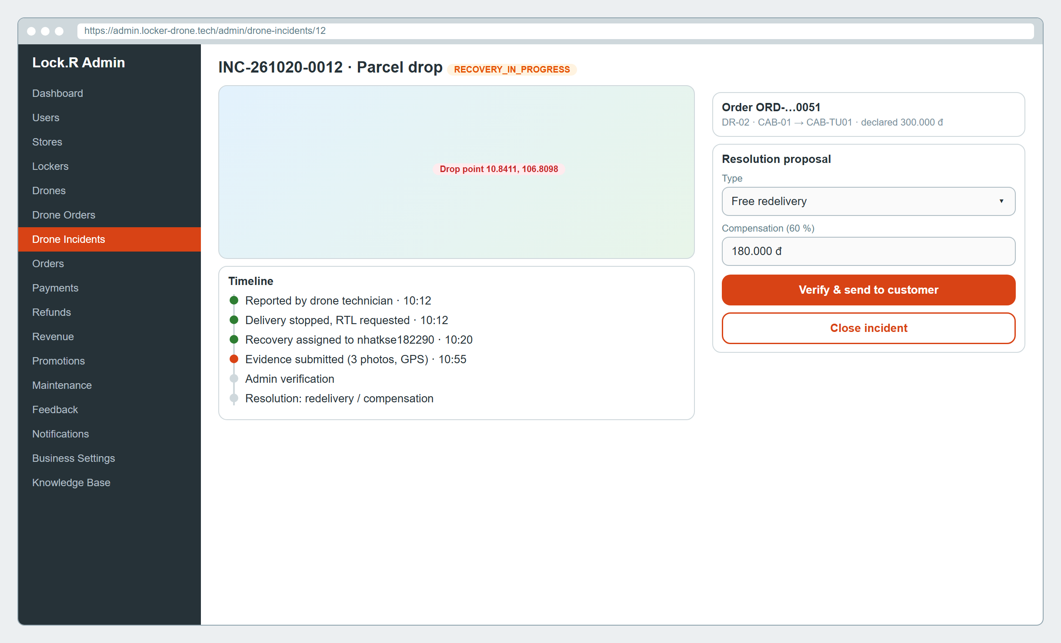
Figure 26. Admin - drone incident details
Function details
- The report (description, photos, last telemetry and camera snapshot when available) stops the delivery and asks for manual RTL.
- Admin assigns a locker technician to recover the parcel (recovery SLA 4 h); the technician checks in by GPS, uploads evidence and submits for verification.
- Admin verifies and proposes free redelivery or compensation (default 60 % of declared value, shipping fee refunded); approval is required.
- The customer accepts or asks for review (when allowed). The technician confirms hand-over to the hub; admin closes the incident. Every step is written to the incident timeline.

3.6 Wallet, Promotion & Loyalty

3.6.1 Wallet Top-up & Withdrawal
Function trigger
Profile -> Transactions -> 'Nạp ví' / 'Rút tiền'.
Function description
Actors: Customer, Administrator. Moves money into and out of the Lock.R wallet.
Screen layout
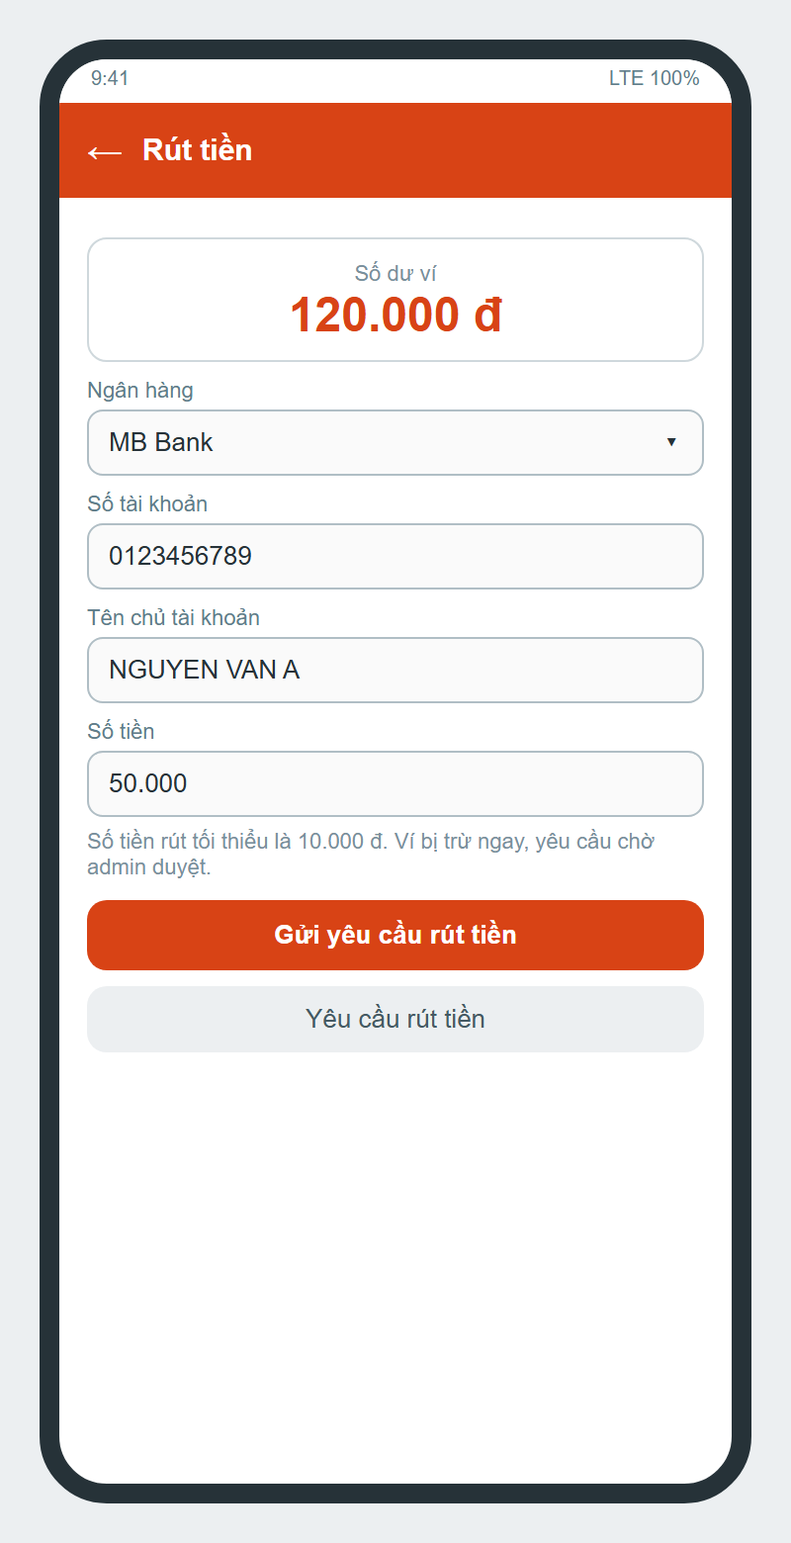
Figure 27. Withdraw
Function details
- Top-up: 1,000 - 50,000,000 VND per time (default 100,000, quick presets) by VietQR; the balance increases only after the SePay webhook. The app shows success only when the money is in.
- Withdraw: bank, account number, account holder, amount >= 10,000 VND and <= balance. The wallet is debited immediately and the request is 'Chờ duyệt'.
- Admin approves after a manual transfer or rejects (money returned to the wallet). Every movement is written to wallet_transactions with the balance after.

3.6.2 Vouchers & Loyalty Points
Function trigger
Profile -> 'Ưu đãi', 'Ưu đãi của tôi', 'Điểm thưởng'; checkout screens.
Function description
Actors: Customer. Uses promotions and points to reduce the price.
Function details
- Promotion: code, % or fixed amount, max discount, min order, period, total / per-user limits, system-wide or one locker. The app only lists vouchers valid for the selected locker.
- Max vouchers per order is configurable (default 1; 0 suspends vouchers).
- Earn: 1 point per 1,000 VND paid when an order is completed. Tiers by lifetime points: Silver 500, Gold 2,000, Platinum 5,000; spending points never lowers the tier.
- Redeem: 1 point = 100 VND, at least 10 points, at most 50 % of the remaining order amount after vouchers; an order of 0 VND counts as paid. Cancel / refund returns points and voucher usage.

3.7 Maintenance

3.7.1 Report Locker Incident
Function trigger
Order details -> 'Báo ô lỗi', or Profile -> 'Báo sự cố'.
Function description
Actors: Customer (also technicians). Reports a faulty box or locker.
Screen layout
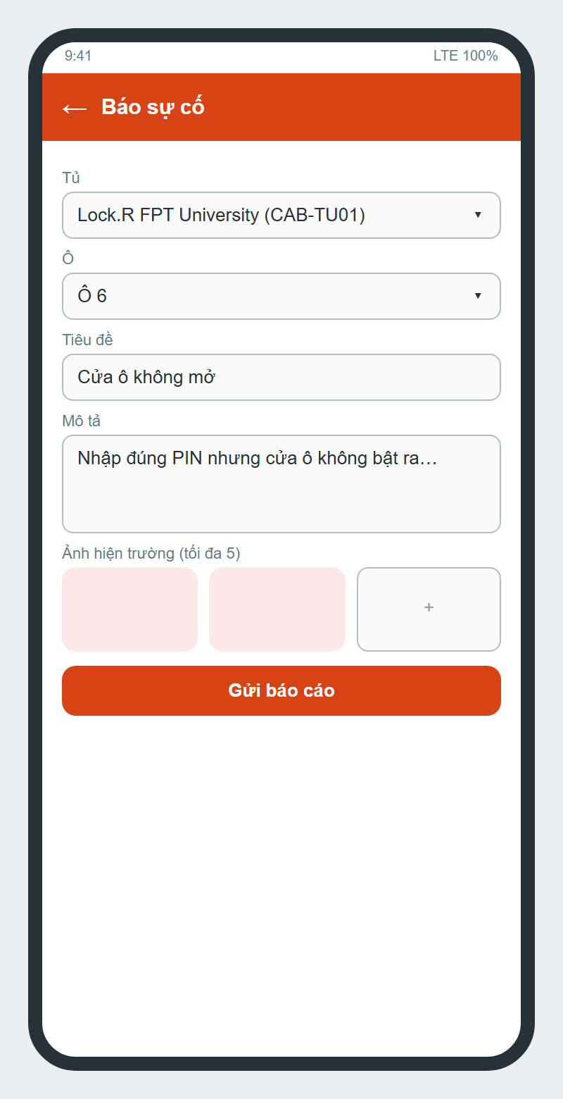
Figure 28. Create incident report
Function details
- Inputs: locker, box, title, description, up to 5 photos per request (10 per ticket from the reporter).
- The box becomes FAULT (previous status remembered), duplicate reports of the same box join the open ticket; a report that blocks the locker sets the locker to MAINTENANCE.
- The ticket (OPEN) is routed to the locker's responsible technician, or to all locker technicians if none, with SLA 4 h.
- The reporter follows progress in 'Báo cáo của tôi' and rates the technician after resolution.

3.7.2 Handle & Resolve Ticket
Function trigger
Locker Technician Home -> 'Sự cố' -> 'Nhận việc'.
Function description
Actors: Locker Technician, Administrator. Fixes the problem and returns the box to service.
Screen layout
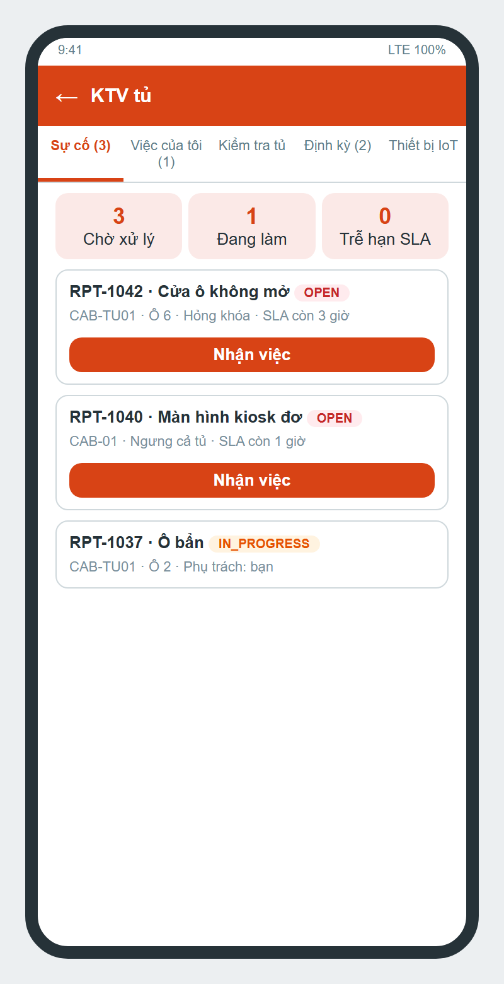
Figure 29. Locker technician home
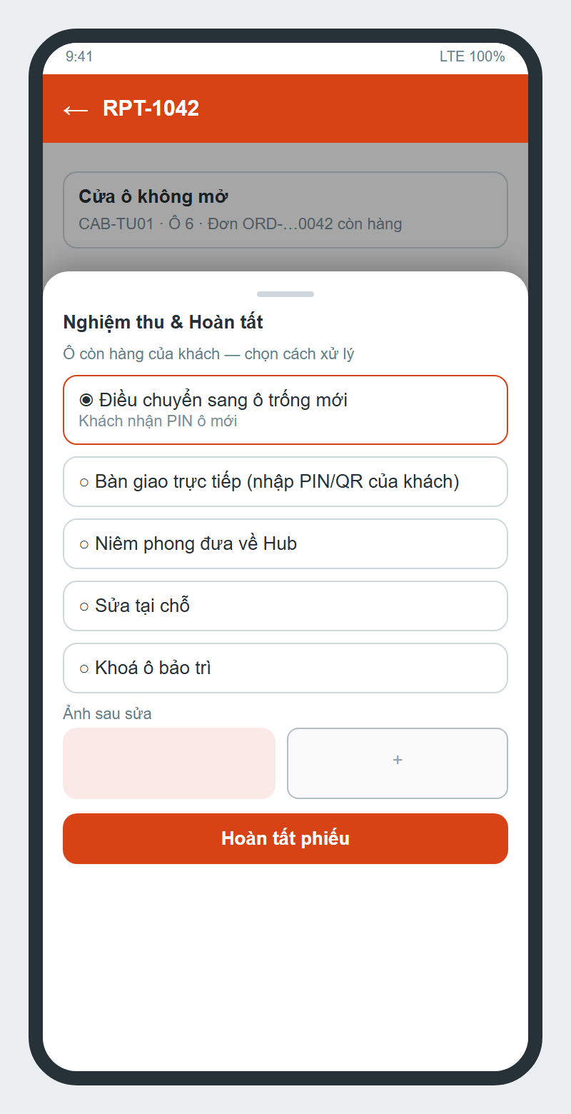
Figure 30. Resolve ticket
Function details
- Claim moves the ticket to IN_PROGRESS under 'Việc của tôi'. Technicians with 3 or more overdue tickets cannot claim (penalty levels: warning 1, restricted 3, suspended 5).
- Progress logs and photos (before / during / after) are recorded; photos up to 10 per request.
- If the box holds a customer's parcel the technician must choose: relocate to a new free box (customer gets the new PIN), hand over directly (customer PIN / QR required), seal to hub (seal code), fix on site, or lock the box.
- 'Nghiệm thu & Hoàn tất' sets RESOLVED and returns the box to its status before the fault. SLA can be extended only by the holder, max 2 times x 24 h with a reason; the ticket can be returned to the queue with a reason.

3.7.3 Periodic Inspection
Function trigger
Tab 'Định kỳ' when an inspection is due (reminder at 07:00, 24 h before).
Function description
Actors: Locker Technician, Drone Technician, Administrator. Regular checks of lockers and drones.
Function details
- Admin creates schedules: locker or drone, checklist, interval in days, assigned technician, time slot.
- The technician marks each item Pass / Fail with photos and a note.
- Any Fail opens a ticket assigned to the same technician (a failed drone becomes FAULT); the next due date moves to the next interval.

3.7.4 Emergency Open & IoT Devices
Function trigger
Technician -> box -> 'Mở tủ khẩn cấp (Master)'; tab 'Thiết bị IoT'.
Function description
Actors: Locker Technician, Locker controller. Opens a box without the customer's code and manages controllers.
Function details
- A reason (and note / photo from a ticket) is mandatory; the command is logged as MASTER with the reason.
- The app shows the real result: opened, timeout (no answer in 20 s), error or jammed; jammed marks the box FAULT and opens a ticket.
- IoT devices: controllers of the technician's lockers with last seen time; 'Khởi động lại thiết bị' sends cabinet/{lockerId}/command/restart and shows the result.

3.8 Administration

3.8.1 Manage Users & Staff
Function trigger
Admin web -> Users.
Function description
Actors: Administrator. Maintains customer and staff accounts.
Screen layout
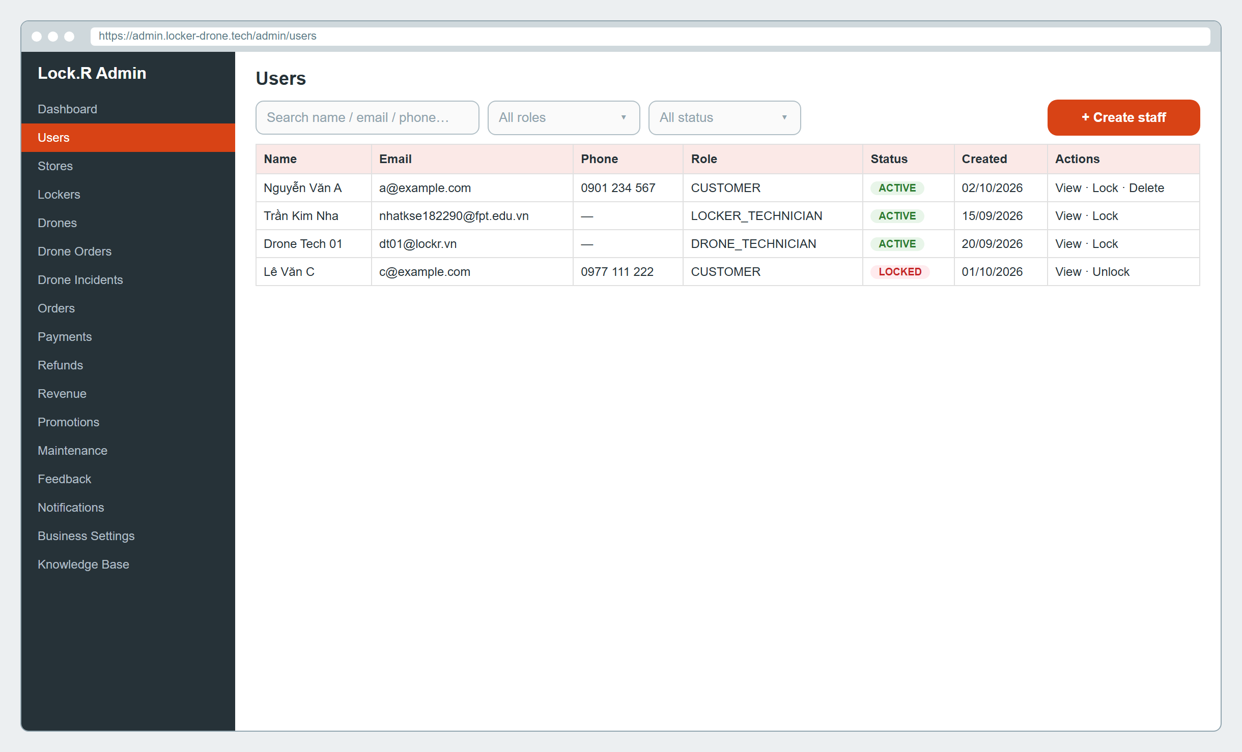
Figure 31. Admin - users
Function details
- Search by name / email / phone, filter by role and status, view details and orders.
- Create staff with role LOCKER_TECHNICIAN or DRONE_TECHNICIAN (duplicate email / phone rejected); the account can log in to the app immediately.
- Lock: refresh tokens revoked, access blocked within ~30 s. Delete: account disabled, email and phone released for new registration.
- Only ADMIN may change roles or status; non-admin requests to /api/users/** are limited to the owner.

3.8.2 Manage Lockers, Boxes & Controllers
Function trigger
Admin web -> Lockers -> a locker.
Function description
Actors: Administrator. Configures physical lockers.
Screen layout
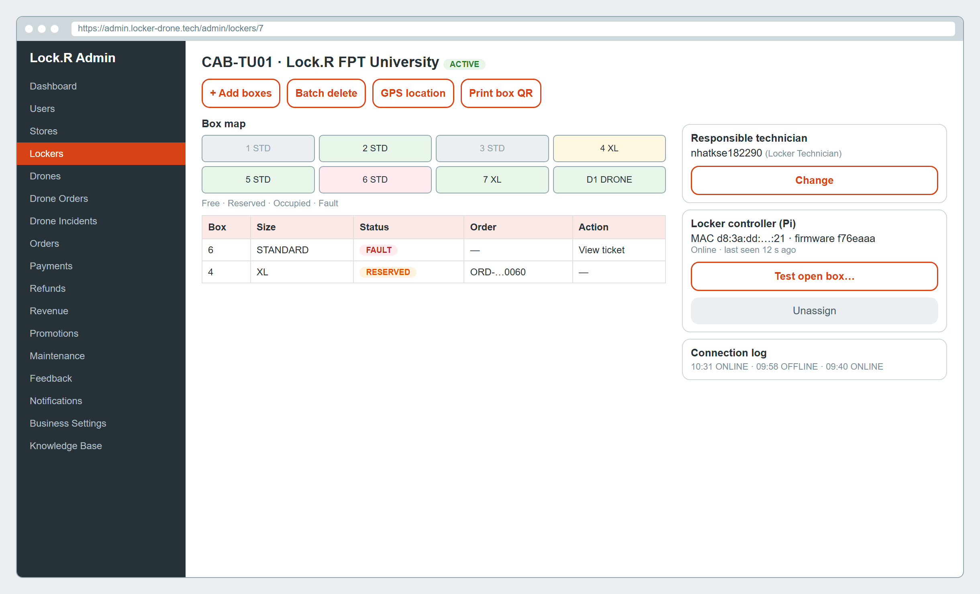
Figure 32. Admin - locker layout
Function details
- Locker: store, code, name, address, exact GPS (map picker), status, landing pad, responsible technician.
- Boxes: add one or a batch, delete (not when occupied), size and cell type, grid position, print box QR, ArUco marker for DRONE boxes.
- Controller: assign a Raspberry Pi by MAC, push the box layout, test-open each box, unassign; connection log shows ONLINE / OFFLINE events.

3.8.3 Process Refunds & Withdrawals
Function trigger
Admin web -> Refunds.
Function description
Actors: Administrator. Pays money back to customers.
Screen layout
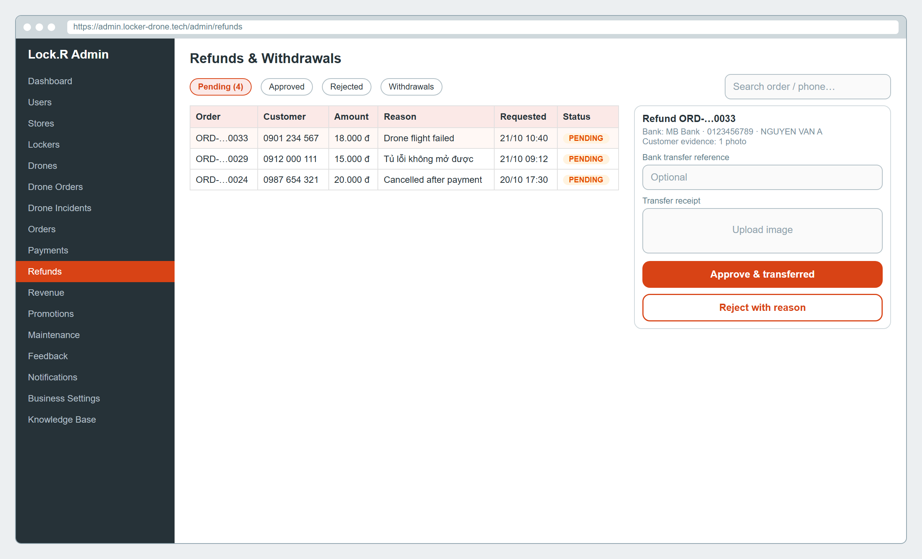
Figure 33. Admin - refunds
Function details
- Tabs Pending / Approved / Rejected / Withdrawals with search.
- Approve: the admin transfers to the shown bank account and uploads the receipt (bank reference optional by setting) -> REFUNDED, customer notified.
- Reject: reason required; withdrawal rejection returns the money to the wallet.
- Refund requests are accepted within 7 days of payment and at least 1,000 VND.

3.8.4 Configure Business Settings
Function trigger
Admin web -> Business Settings.
Function description
Actors: Administrator. Changes business rules without redeploying.
Screen layout
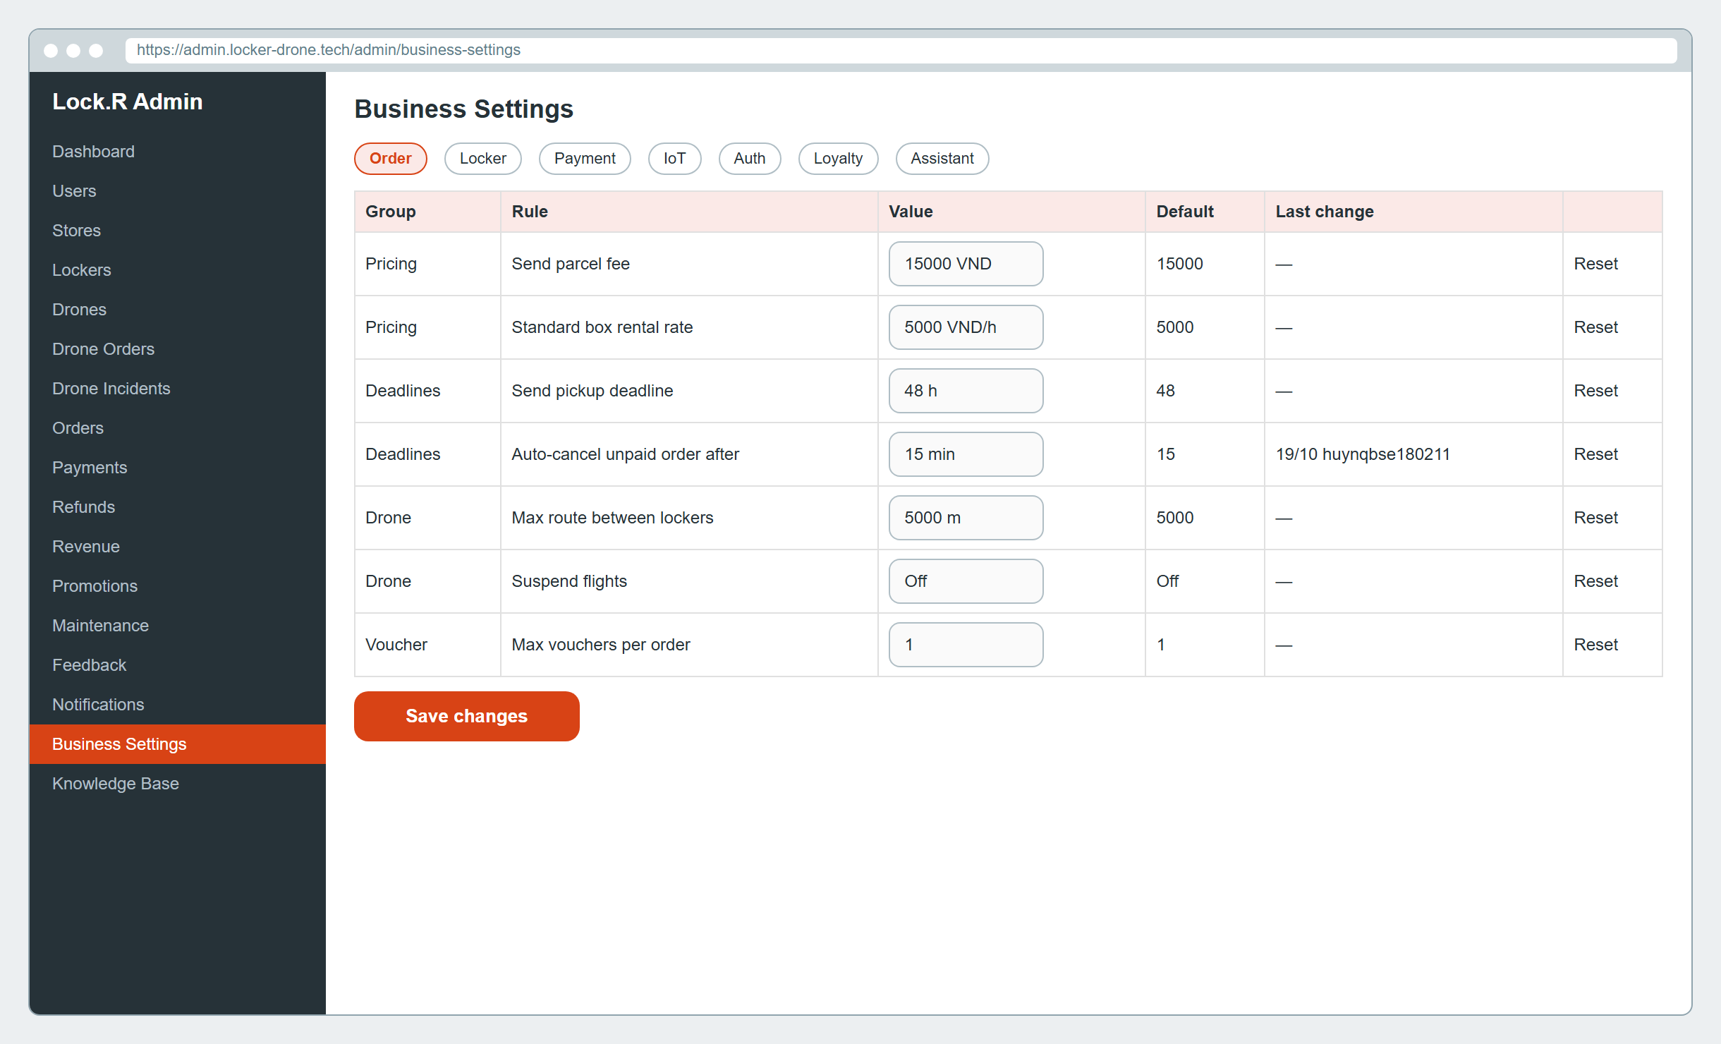
Figure 34. Admin - business settings
Function details
- Settings are grouped by service scope (order, locker, payment, iot, auth, loyalty, assistant, store); each shows value, default, unit and last change.
- Values are validated by type (integer, decimal, boolean, string, list) and range; 'Reset' restores the default. Every change is audited.
- Public rules (prices, rental hours, weight options…) are read by the app and kiosk, so changes apply immediately.

3.8.5 Dashboard & Reports
Function trigger
Admin web -> Dashboard / Orders / Payments / Revenue.
Function description
Actors: Administrator. Monitors the business.
Function details
- Dashboard: revenue, orders by status, peak hours, user growth, top locations (real data only).
- Revenue by money actually collected, by service, locker and period (max 366 days per query).
- Times are shown in Vietnam time HH:mm:ss dd/MM/yyyy; status values follow the backend enums.

3.8.6 Manage Knowledge Base
Function trigger
Admin web -> Knowledge Base.
Function description
Actors: Administrator. Feeds the AI assistant.
Function details
- Upload MD / TXT / HTML / PDF / DOCX up to 20 MB and choose the roles allowed to read it.
- Indexing: PENDING -> INDEXING -> READY / FAILED; the admin can view the original file and each chunk.
- Conversations and ratings are visible; the evaluation set measures retrieval at the configured relevance threshold.

3.9 AI Assistant

3.9.1 Ask the AI Assistant
Function trigger
Bottom navigation 'Trợ lý AI'.
Function description
Actors: Customer, Locker Technician, Drone Technician. Answers questions from internal documents and the user's own orders.
Screen layout
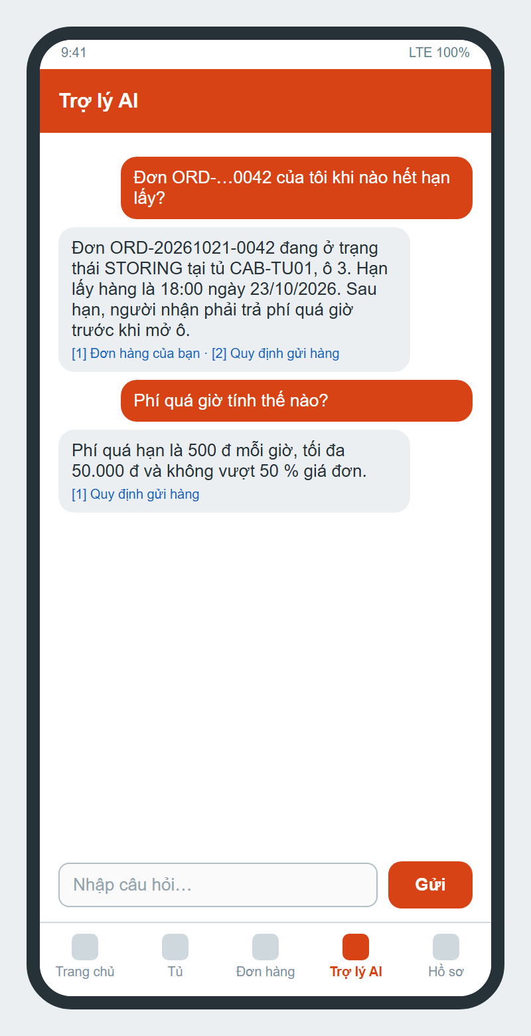
Figure 35. AI assistant
Function details
- The question is embedded (Voyage) and the most similar chunks are retrieved only from documents the user's role may read; Claude answers with citations.
- Below the relevance threshold the assistant replies that the documents do not cover the question and does not call the LLM. Questions per hour are limited.
- Questions about orders (order code or natural language, with or without Vietnamese diacritics) are answered from the user's own orders and orders sent to the user.
- History of conversations is kept; users can rate answers.

4. Non-Functional Requirements

4.1 External Interfaces
Interface | Description
User interfaces | Mobile app (Android / iOS, Flutter) and mobile web for customers and technicians in Vietnamese; admin web (React) in English / Vietnamese / Japanese; kiosk web UI on a 7-inch 1024 x 600 touch screen with on-screen keyboard; landing page locker-drone.tech.
Hardware interfaces | Locker: Raspberry Pi 5 drives relays, lock signal lines, door sensors and a TB6600 stepper driver for the sliding lid by GPIO (RS485 Arduino optional); BLE beacon for proximity unlock. Drone: Raspberry Pi 5 reads Pixhawk 6C (ArduPilot) over MAVLink and streams camera MJPEG.
Software interfaces | SePay (VietQR, webhook), Firebase Authentication and Cloud Messaging, SMTP email, eSMS.vn / Twilio SMS, Cloudinary signed upload, Anthropic Claude (answers with citations), Voyage AI (embeddings), OpenStreetMap / OSRM (maps, routes).
Communication interfaces | HTTPS REST through the API gateway (https://api.locker-drone.tech) with JWT; STOMP over WebSocket /ws for realtime updates; MQTT (Mosquitto, wss with per-device account and ACL) between backend, lockers and drones; RabbitMQ events between services.

4.2 Quality Attributes

4.2.1 Usability
- A new customer can send a parcel (create, pay, drop) in under 3 minutes without training; a receiver can pick up with only the PIN in under 30 seconds.
- Customer and technician apps use Vietnamese; times are displayed in Vietnam time (UTC+7); money in VND with thousand separators.
- Every error shows a clear message (see 5.3) and the next possible action; destructive actions (cancel order, emergency open, delete) require confirmation.
- Kiosk screens fit 1024 x 600 with large touch targets and an on-screen keyboard; layouts do not overflow on 360 dp wide phones.

4.2.2 Reliability
- Availability target: 99 % per month for the API during service hours; a failed deploy is rolled back to the previous release automatically (smoke test after deploy).
- Payments are idempotent: duplicate webhooks and repeated events never add money twice; orders become PAID only when the received amount covers the total.
- Box state is reconciled every hour with active orders; reserved boxes are released by two independent sweeps.
- The locker controller reconnects to MQTT automatically after network loss; an open command without acknowledgement within 20 s is reported as timeout, never as success.
- Critical defect: any loss of a customer's parcel, wrong box opened or money charged twice; must be fixed before the next release.

4.2.3 Performance
- API response time: 95 % of read requests under 1 s, write requests under 2 s on the production VM (2 vCPU, 8 GB RAM).
- Box open: command delivered to the controller and result shown within 5 s in normal conditions (timeout 20 s).
- Realtime: order status / drone position updates reach the app within 2 s; drone telemetry is sent every second.
- AI assistant answers within 10 s; document indexing starts within 5 s after upload.
- Capacity for the pilot: 1,000 registered users, 20 lockers, 10 drones and 100 concurrent app sessions.

4.2.4 Security
- All traffic uses HTTPS / WSS; passwords are hashed, OTPs and refresh tokens are stored hashed; secrets live only in the server .env, never in the repositories.
- Role-based access at the gateway plus owner checks in services; admin login requires email OTP (2FA).
- PIN brute force is prevented by locking the box after 5 wrong attempts for 15 minutes.
- MQTT devices have one account each and an ACL limited to their own locker topics; drone telemetry is signed (HMAC) and rejected when stale.

4.2.5 Maintainability & Portability
- Backend is split into microservices (Spring Boot, Java 21) with one database per service and Flyway migrations; every change goes through a pull request and CI tests.
- Business rules are data (system_settings), editable by admin without code changes.
- The mobile app runs on Android, iOS and the web from one Flutter code base; the kiosk is a web app that runs on any Raspberry Pi with Chromium.

5. Requirement Appendix

5.1 Business Rules
ID | Rule Definition
BR-01 | A SEND order costs 15,000 VND; a drone delivery costs 15,000 VND including 500 g plus 3,000 VND for each started 250 g step above 500 g; box rental costs 5,000 VND/hour (Standard) or 10,000 VND/hour (XL).
BR-02 | Payment is required before dropping a parcel. An order is PAID only when the money received covers the total amount.
BR-03 | Unpaid orders are cancelled after 15 minutes (drone orders after 30 minutes); orders not dropped are cancelled after 24 hours; their boxes are released.
BR-04 | A box is held (RESERVED) at most 24 hours.
BR-05 | The receiver must pick up a SEND parcel within 48 hours and a drone parcel within 24 hours.
BR-06 | Overdue pickup fee: 500 VND per hour, at most 50,000 VND and at most 50 % of the order price, with 15 minutes of grace after paying; the box opens only after the fee is paid.
BR-07 | Orders overdue for more than 72 hours become EXPIRED, the parcel is moved to the warehouse and the box is released.
BR-08 | Rental time is 1 to 720 hours; each extension is at most 24 hours; time after the rental end is charged at 100 % of the hourly rate.
BR-09 | Each pickup PIN has 6 digits; after 5 wrong attempts the box is locked for 15 minutes. Changing or delegating a PIN invalidates the old one.
BR-10 | A drone order needs a receiver locker with a landing pad and a free DRONE box within 5,000 m, parcel weight up to 5,000 g, size within 30 x 25 x 20 cm and declared value up to 2,000,000 VND; a customer may have at most 3 open drone orders.
BR-11 | A drone may accept an order only with battery >= 20 %; launch is allowed only within flight hours and when flights are not suspended.
BR-12 | If the measured weight exceeds the declared weight by more than 50 g, the fee is recalculated and the customer must pay the difference within 60 minutes or the order is cancelled and refunded.
BR-13 | Home pickup offers last 180 s; the technician must arrive within 60 minutes and the drone must launch within 120 minutes after pickup; otherwise the order fails and is refunded.
BR-14 | Parcel drop: suggested compensation is 60 % of the declared value with the shipping fee refunded, or free redelivery; compensation requires admin approval; recovery SLA is 4 hours.
BR-15 | Refunds are paid to the customer's bank account by the admin with a transfer receipt; a refund request must be made within 7 days and be at least 1,000 VND.
BR-16 | Wallet top-up is 1,000 to 50,000,000 VND per time; withdrawal is at least 10,000 VND and is debited immediately until approved or rejected.
BR-17 | Customers earn 1 loyalty point per 1,000 VND paid on completed orders. Tiers: Silver 500, Gold 2,000, Platinum 5,000 lifetime points.
BR-18 | When paying with points: 1 point = 100 VND, at least 10 points, at most 50 % of the order after vouchers; at most 1 voucher per order by default.
BR-19 | A ticket has an SLA of 4 hours; the technician holding it may extend it at most 2 times x 24 hours with a reason. Technicians with 3 or more overdue tickets cannot claim new tickets.
BR-20 | A locker in MAINTENANCE or offline cannot be booked. A box holding a customer's parcel can only be resolved by relocation, hand-over with the customer's code, sealing to the hub, fixing on site or locking.
BR-21 | Email OTP has 6 digits and expires after 300 seconds; registration / 2FA temporary tokens expire after 600 seconds; kiosk login QR expires after 2 minutes.
BR-22 | Only SePay bank transfer (VietQR) is enabled for customers; MoMo, VNPay and cash are not accepted.
BR-23 | All values above are defaults stored in system_settings and can be changed by the administrator; every change is audited.

5.2 Common Requirements
- All dates and times are stored in UTC and displayed in Vietnam time (UTC+7) with format HH:mm dd/MM/yyyy (admin web HH:mm:ss dd/MM/yyyy).
- Money is in VND, integer, displayed with '.' as thousand separator and the suffix 'đ'.
- Phone numbers are Vietnamese mobile numbers (10 digits, stored in +84 format); emails are validated and unique per account.
- Lists use pagination (default 20 items) with search and filters; empty lists show an explanatory empty state.
- Every protected API call carries the JWT access token; an expired token is refreshed once silently, otherwise the user is sent to login.
- Every state change of an order, ticket or incident is written to its history with actor and time and triggers a notification to the affected users.
- Images are uploaded directly to Cloudinary with a server signature; max 5-10 photos per request depending on the role.
- Destructive or irreversible actions require a confirmation dialog.

5.3 Application Messages List
# | Message code | Message Type | Context | Content
1 | MSG01 | Inline, red, under the field | Required field is empty | Trường này là bắt buộc
2 | MSG02 | Inline, red, under the field | Email has wrong format | Email không hợp lệ
3 | MSG03 | Inline, red, under the field | Phone has wrong format | Số điện thoại không hợp lệ
4 | MSG04 | Inline, red, under the field | Password shorter than 6 characters | Mật khẩu phải có ít nhất 6 ký tự
5 | MSG05 | Inline, red, under the field | Password and confirmation differ | Mật khẩu không khớp
6 | MSG06 | Toast | Wrong login credentials | Thông tin đăng nhập không hợp lệ
7 | MSG07 | Toast | Email already used when registering | Email đã tồn tại
8 | MSG08 | Toast | Registration succeeded | Đăng ký thành công!
9 | MSG09 | Toast | No network connection | Lỗi kết nối mạng
10 | MSG10 | Toast | Server error | Lỗi máy chủ
11 | MSG11 | Toast | Profile updated | Cập nhật hồ sơ thành công
12 | MSG12 | Dialog | User leaves an unpaid new order | Hủy tạo đơn hàng? — [Hủy đơn & Thoát] [Ở lại thanh toán]
13 | MSG13 | Toast | Selected receiver locker has no free drone box | Tủ nhận này đã hết ô drone trống, hãy chọn tủ khác
14 | MSG14 | Inline, red | Drone booking without the prohibited-goods commitment | Bạn cần cam kết kiện không chứa hàng cấm bay
15 | MSG15 | Inline, red | Withdrawal below the minimum | Số tiền rút tối thiểu là 10.000 đ
16 | MSG16 | Toast | Refund request sent | Đã gửi yêu cầu hoàn tiền thành công!
17 | MSG17 | Inline, red | Refund request without reason | Vui lòng nhập lý do yêu cầu hoàn tiền
18 | MSG18 | Toast | Copy PIN / order code | Đã sao chép mã PIN / Đã sao chép mã đơn hàng
19 | MSG19 | Toast | Technician starts / ends shift | Đã vào ca làm việc và kích hoạt định vị GPS. / Đã kết thúc ca và tắt định vị GPS.
20 | MSG20 | Inline, red | Drone status FAULT without reason | Cần nhập lý do khi chuyển sang FAULT
21 | MSG21 | Kiosk banner, red | Wrong PIN at kiosk | Mã PIN không hợp lệ
22 | MSG22 | Kiosk banner, red | Too many wrong PINs | Nhập sai quá số lần cho phép! Thao tác bị tạm khóa. Vui lòng vào App Mobile để "Cấp lại mã PIN" rồi thử lại.
23 | MSG23 | Kiosk banner, red | Code not found or expired | Mã không hợp lệ hoặc đã hết hạn
24 | MSG24 | Kiosk banner | Kiosk login QR expired | Mã QR đã hết hạn.
25 | MSG25 | Kiosk banner | Too many QR requests | Tạo mã quá nhiều lần. Vui lòng thử lại sau ít phút.
26 | MSG26 | Kiosk banner, red | Wrong / expired email OTP at kiosk | Mã OTP không đúng. Vui lòng thử lại. / Mã OTP đã hết hạn. Vui lòng quay lại và gửi lại.
27 | MSG27 | Kiosk banner | Transfer not yet received | Chưa ghi nhận được thanh toán. Vui lòng thử lại sau giây lát.
28 | MSG28 | Kiosk banner, red | VietQR could not be created | Không tạo được mã VietQR. Vui lòng thử lại.
29 | MSG29 | Kiosk info | Rental box closed, rental continues | Nhớ đóng cửa ô. Mã PIN vẫn dùng được tới khi hết hạn thuê.
30 | MSG30 | API error code | Opening a box of an unpaid order / unpaid overtime | ORDER_UNPAID / OVERTIME_FEE_UNPAID / RENTAL_EXPIRED
31 | MSG31 | API error code | Payment with a disabled method | PAYMENT_METHOD_UNSUPPORTED

5.4 Other Requirements - Status Values
Object | Values
Order status | INITIALIZED, AWAITING_DISPATCH, STORING, COMPLETED, CANCELED, EXPIRED, REFUND_PENDING, REFUNDED
Payment status | UNPAID, PAID, REFUND_PENDING, REFUNDED
Order type | SEND, RENTAL, STORAGE, DRONE_DELIVERY
Delivery stage (drone) | AWAITING_DISPATCH, LAUNCHING, DEPARTED, EN_ROUTE, APPROACHING, ARRIVED, READY_FOR_PICKUP
Box status | AVAILABLE, RESERVED, OCCUPIED, FAULT (cell type STANDARD, XL, DRONE)
Drone status | IDLE, RESERVED, IN_FLIGHT, CHARGING, MAINTENANCE, FAULT
Ticket status | OPEN, IN_PROGRESS, RESOLVED
Roles | CUSTOMER, LOCKER_TECHNICIAN, DRONE_TECHNICIAN, ADMIN

